Department of Computer and Software Technology
Faculty of Computing
Topic: A zero-trust network monitoring framework with automated threat prevention and anomaly detection
CHAPTER ONE
INTRODUCTION
1.1 Background to the Study
The rapid growth of information and communication technology has transformed the way individuals, businesses, educational institutions, and government organizations carry out their daily activities. Today, computer networks are used to share information, store important records, provide online services, and support communication across different locations. As more organizations rely on networked systems to perform their operations, protecting these networks has become one of the most important responsibilities of information technology professionals. A secure network ensures that sensitive information remains confidential, available, and protected from unauthorized users (Syed et al., 2022; He et al., 2022).
In recent years, cyber threats have continued to increase in both number and complexity. Attackers constantly develop new techniques to gain unauthorized access to computer systems, steal confidential information, disrupt services, or damage valuable digital resources. These attacks include malware infections, ransomware, phishing attacks, denial-of-service attacks, insider threats, and unauthorized access to organizational networks. As organizations continue to adopt cloud computing, mobile devices, remote work, and Internet of Things (IoT) technologies, the number of connected devices has increased significantly. This has expanded the attack surface, making it easier for cybercriminals to exploit weaknesses within a network (Ahmad et al., 2021; Umer et al., 2022).

Traditionally, many organizations relied on perimeter-based security models to protect their computer networks. This approach assumed that users and devices inside the organizational network could be trusted, while only external users were considered potential threats. Security measures such as firewalls and antivirus software were placed at the boundary of the network to block unauthorized external access. Although this approach was effective when most systems operated within a closed environment, it has become less reliable in today’s interconnected world. Modern organizations allow employees to access company resources remotely through laptops, smartphones, tablets, and cloud services. As a result, attackers can compromise trusted devices or user accounts and gain access to sensitive resources without being detected (Syed et al., 2022; He et al., 2022).
One major challenge facing organizations is that cyber attackers no longer rely only on attacks from outside the network. Insider threats have become increasingly common, where authorized users intentionally or unintentionally expose confidential information or create security vulnerabilities. A compromised employee account may provide attackers with direct access to organizational systems, making it difficult for traditional security models to detect malicious activities. This situation has created the need for stronger security approaches that continuously verify users and devices before granting access to network resources (Syed et al., 2022; Almohri, Watson, & Evans, 2021).
To address these challenges, the Zero Trust security model was introduced as a modern approach to network security. Unlike traditional security methods that assume trust based on network location, Zero Trust follows the principle of “never trust, always verify.” Every user, device, application, and network connection must be verified before access is granted, regardless of whether the request originates from inside or outside the organization’s network. This approach reduces the possibility of unauthorized access by ensuring that every access request is authenticated, authorized, and continuously monitored throughout the communication process (Syed et al., 2022).
Zero Trust Architecture also applies the principle of least privilege, where users are granted only the minimum level of access required to perform their assigned tasks. This reduces the chances of attackers moving freely across the network after compromising a user account. In addition, network segmentation divides the network into smaller sections, preventing cyber threats from spreading easily between different parts of the system. Continuous authentication, access control, device verification, and policy enforcement are important features that make Zero Trust more effective than traditional perimeter-based security (Syed et al., 2022; Cisco Systems, 2022).
While Zero Trust provides stronger access control, it does not completely eliminate cyber threats. Attackers continue to develop sophisticated techniques that can bypass authentication mechanisms or exploit legitimate user accounts. Some malicious activities may occur after access has already been granted, making continuous monitoring an important part of network security. Organizations therefore require intelligent systems that can monitor network traffic continuously and quickly identify suspicious activities before significant damage occurs (He et al., 2022).

Network monitoring is the process of observing and analyzing network traffic, user activities, and system performance to ensure that network resources operate securely and efficiently. A network monitoring system collects information from devices connected to the network and examines communication patterns to detect unusual behavior. Traditional monitoring systems often depend on predefined rules or known attack signatures. Although these methods can detect previously identified threats, they may fail to recognize new or unknown attacks that do not match existing signatures. This limitation makes it difficult to respond effectively to modern cyber threats (Maseer et al., 2024; Campazas-Vega et al., 2023).
Recent developments in artificial intelligence and machine learning have improved the ability of network monitoring systems to detect abnormal behavior automatically. Machine learning algorithms can learn normal network activities from collected data and identify unusual patterns that may indicate cyber attacks. Unlike traditional signature-based systems, machine learning techniques can detect previously unknown attacks by recognizing deviations from normal behavior. This improves detection accuracy and reduces the time required to respond to security incidents (Ahmad et al., 2021; Umer et al., 2022).
Anomaly detection has become an important component of modern cybersecurity systems. It focuses on identifying activities that differ significantly from normal network behavior. Examples of such anomalies include unusual login attempts, unexpected file transfers, abnormal network traffic, unauthorized device connections, and suspicious communication between network devices. Early detection of these abnormal activities allows security administrators to investigate potential threats before they cause serious damage. Integrating anomaly detection with Zero Trust principles provides an additional layer of protection by combining continuous verification with intelligent monitoring (Maseer et al., 2024; Campazas-Vega et al., 2023).
Another important aspect of modern cybersecurity is automated threat prevention. In many organizations, security personnel manually investigate alerts before responding to potential threats. This process can be time-consuming, especially when organizations generate thousands of security alerts every day. Delayed responses increase the risk of attackers achieving their objectives before security teams take action. Automated threat prevention reduces this challenge by allowing the system to respond immediately after detecting suspicious activities. Such responses may include blocking malicious traffic, isolating compromised devices, terminating suspicious user sessions, or restricting access until further verification is completed (Cao et al., 2024; Gambo & Almulhem, 2025).
The integration of Zero Trust principles, intelligent network monitoring, anomaly detection, and automated threat prevention provides a more comprehensive approach to protecting organizational networks. Rather than relying only on access control or only on threat detection, these technologies work together to provide continuous security throughout the entire communication process. Users and devices are continuously verified, network activities are monitored in real time, abnormal behaviors are detected automatically, and appropriate security actions are taken immediately to reduce the impact of cyber attacks (Cao et al., 2024; Gambo & Almulhem, 2025).

Many organizations, particularly in developing countries, still depend on traditional network security approaches that cannot adequately defend against modern cyber threats. Limited security awareness, outdated infrastructure, insufficient monitoring systems, and delayed incident response contribute to increasing cybersecurity risks. There is therefore a growing need to develop intelligent security frameworks capable of protecting network environments from both known and emerging threats while minimizing human intervention (Cao et al., 2024; Gambo & Almulhem, 2025).
This project, titled “A Zero-Trust Network Monitoring Framework with Automated Threat Prevention and Anomaly Detection,” is proposed to address these challenges. The study focuses on designing a security framework that combines the principles of Zero Trust Architecture with intelligent network monitoring and anomaly detection techniques to improve network security. The proposed framework is expected to continuously verify users and devices, monitor network activities in real time, detect suspicious behavior accurately, and initiate automated threat prevention measures to minimize security risks. By integrating these security mechanisms into a unified framework, the study seeks to improve the confidentiality, integrity, and availability of organizational network resources while providing a proactive approach to cybersecurity (Syed et al., 2022; Alalmaie et al., 2024).
1.2 Statement of the Problem
The increasing dependence on computer networks for communication, business transactions, cloud computing, online learning, financial services, and data storage has made network security a major concern for organizations around the world. Every day, sensitive information is transmitted across networks, making them attractive targets for cybercriminals. As cyber attacks continue to increase in frequency and sophistication, many organizations struggle to adequately protect their systems against unauthorized access, data breaches, malware infections, insider threats, and other forms of cyber attacks (Ahmad et al., 2021; Ahmad et al., 2021).
Many organizations still rely on traditional network security approaches that focus mainly on protecting the network perimeter through firewalls, antivirus software, and intrusion detection systems. While these security measures provide a certain level of protection, they are no longer sufficient to defend against modern cyber threats. Once an attacker successfully bypasses the network perimeter or compromises a legitimate user’s account, they may gain unrestricted access to sensitive resources without being detected immediately. This weakness increases the risk of data theft, service disruption, and financial loss (Syed et al., 2022; He et al., 2022).
Another major challenge is the inability of many existing network monitoring systems to detect new and unknown cyber threats in real time. Most traditional monitoring solutions depend on predefined rules or attack signatures, making them effective only against previously identified attacks. As cybercriminals continuously develop new attack techniques, these systems often fail to recognize abnormal activities that do not match existing attack patterns. Consequently, organizations may not discover security incidents until significant damage has already occurred (Chen et al., 2022; Nguyen et al., 2023).
Furthermore, many organizations still rely heavily on manual security monitoring and incident response. Security personnel are expected to examine large volumes of network alerts before taking appropriate actions. This process is time-consuming and increases the possibility of delayed responses, especially in large network environments where thousands of events are generated every day. The delay between threat detection and response allows attackers to continue their malicious activities, increasing the severity of security incidents (Khan et al., 2022; Camacho et al., 2021).
Although the Zero Trust security model improves access control by continuously verifying users and devices before granting access to network resources, many existing Zero Trust implementations focus mainly on authentication and authorization without integrating intelligent anomaly detection and automated threat prevention. As a result, suspicious activities occurring after authentication may remain undetected or require manual intervention before appropriate security measures are taken (Rose et al., 2020; Almohri et al., 2021; Cisco Systems, 2022).
Therefore, there is a need to develop a Zero-Trust Network Monitoring Framework with Automated Threat Prevention and Anomaly Detection that combines continuous identity verification, intelligent network monitoring, anomaly detection, and automated threat response into a unified security framework. Such a framework will improve the ability to detect abnormal network activities in real time, reduce unauthorized access, minimize response time to cyber threats, and enhance the overall security of organizational networks (Cao et al., 2024; Gambo & Almulhem, 2025).
1.3 Aim and Objectives of the Study
Aim of the Study
The aim of this study is to design and develop a Zero-Trust Network Monitoring Framework with Automated Threat Prevention and Anomaly Detection for improving network security through continuous monitoring, intelligent anomaly detection, and automated response to cyber threats.
Objectives of the Study
The specific objectives of this study are to:
I design a Zero Trust network monitoring framework that continuously verifies users and devices before granting access to network resources.
Ii develop an intelligent anomaly detection mechanism capable of identifying suspicious network activities in real time.
III Implement an automated threat prevention mechanism that responds to detected threats by restricting or blocking unauthorized activities.
Iv evaluate the effectiveness of the proposed framework in improving network security, reducing unauthorized access, and enhancing threat detection accuracy.
1.4 Significance of the Study
The importance of network security continues to increase as organizations depend more on digital technologies to perform their daily activities. Cyber attacks have become more sophisticated, making it necessary to adopt security approaches that can prevent unauthorized access, detect threats early, and respond quickly before significant damage occurs. This study is therefore important because it proposes a security framework that combines Zero Trust principles with network monitoring, anomaly detection, and automated threat prevention to improve the protection of computer networks (Rose et al., 2020; Cao et al., 2024).
This study will contribute to the advancement of cybersecurity practices by demonstrating how different security technologies can be integrated into a single framework to provide stronger protection against modern cyber threats. The proposed framework is expected to improve the confidentiality, integrity, and availability of information by reducing security risks associated with unauthorized access and malicious network activities. (Alalmaie et al., 2024; Cao et al., 2024)
The study is also important because it promotes a proactive approach to cybersecurity. Instead of waiting for attacks to occur before taking action, the proposed framework focuses on continuously monitoring network activities, identifying suspicious behaviour at an early stage, and responding automatically to minimize the impact of cyber attacks. This approach will help organizations improve their overall security posture and reduce the financial and operational losses associated with cyber incidents. (Cao et al., 2024; Gambo & Almulhem, 2025)
Beneficiaries of the Study
Organizations
Organizations will benefit from this study because the proposed framework provides stronger protection for network resources through continuous verification of users and devices before access is granted. This will reduce the possibility of unauthorized access, data breaches, and insider threats. (Syed et al., 2022; Dhiman et al., 2024)
Network Administrators and Cybersecurity Professionals
The proposed framework will assist network administrators and cybersecurity professionals by providing continuous monitoring of network activities and automated threat detection capabilities. This will reduce the workload associated with manual monitoring and improve the speed and efficiency of incident response. (Cao et al., 2024; Syed et al., 2022)
Educational Institutions
Universities, schools, and research institutions can adopt the framework to improve the security of their network infrastructure and protect sensitive academic and administrative information from cyber threats. (Syed et al., 2022; Kang et al., 2023)
Researchers and Students
The study will serve as a valuable reference material for researchers and students in Computer Science, Cybersecurity, Information Technology, and related disciplines. It can support future studies in Zero Trust Architecture, anomaly detection, machine learning in cybersecurity, and automated threat prevention. (Gambo & Almulhem, 2025; Alalmaie et al., 2024)
Government Agencies and Public Institutions
Government organizations that manage critical information systems can benefit from the framework by improving the security of public data and reducing vulnerabilities to cyber attacks. (Syed et al., 2022; Dhiman et al., 2024)
The Cybersecurity Community
The findings of this study may encourage further research into intelligent and adaptive cybersecurity solutions that integrate Zero Trust principles with artificial intelligence and automated response mechanisms. (Gambo & Almulhem, 2025; Cao et al., 2024)
1.5 Scope of the Study
This study focuses on the design and development of a Zero-Trust Network Monitoring Framework with Automated Threat Prevention and Anomaly Detection. The study is limited to the application of Zero Trust principles for improving network security through continuous user and device verification, intelligent network monitoring, anomaly detection, and automated threat prevention. (Syed et al., 2022; Alalmaie et al., 2024)
The proposed framework is designed to monitor network activities, identify suspicious behaviour using anomaly detection techniques, and initiate automated security responses whenever abnormal activities are detected. The study also examines how Zero Trust principles can be integrated with intelligent monitoring mechanisms to strengthen access control and improve the overall security of organizational networks. (Maseer et al., 2024; Cao et al., 2024)
The study does not cover the implementation of physical network security, hardware security devices, digital forensics, penetration testing, or malware development. It is also limited to the conceptual design and evaluation of the proposed framework within the scope of network security and cybersecurity. Other areas of information security that are not directly related to Zero Trust network monitoring are beyond the scope of this research. (Syed et al., 2022; Dhiman et al., 2024)
1.6 Definition of Terms
Zero Trust Architecture (ZTA): A cybersecurity approach that requires every user, device, and application to be continuously verified before access to network resources is granted, regardless of their location. (Syed et al., 2022)
Network Monitoring: The continuous observation and analysis of network activities to ensure the proper performance, availability, and security of a computer network. (Kang et al., 2023)
Anomaly Detection: The process of identifying unusual or suspicious activities that differ from normal network behaviour and may indicate a cyber attack or security threat. (Maseer et al., 2024)
Automated Threat Prevention: The ability of a security system to automatically detect, block, isolate, or respond to cyber threats without requiring immediate human intervention. (Cao et al., 2024)
Cybersecurity: The practice of protecting computer systems, networks, software, and digital information from unauthorized access, attacks, damage, or theft. (Syed et al., 2022)
Machine Learning: A branch of artificial intelligence that enables computer systems to learn from data and improve their ability to identify patterns and make decisions without being explicitly programmed for every situation. (Ahmad et al., 2021)
Artificial Intelligence (AI): The simulation of human intelligence by computer systems to perform tasks such as learning, reasoning, decision-making, and problem-solving. (Pawlicki et al., 2024)
Access Control: A security mechanism used to regulate who or what can access specific network resources based on predefined authorization policies. (Dhiman et al., 2024)
Authentication: The process of verifying the identity of a user, device, or application before access to a system or network is granted. (He et al., 2022)
Authorization: The process of determining the level of access or permissions that an authenticated user or device is allowed within a computer network. (Kang et al., 2023)

CHAPTER TWO
2.1 Conceptual Review
2.1.1 Zero Trust Architecture (ZTA)
Zero Trust Architecture (ZTA) is a modern cybersecurity approach that has gained significant attention because of the increasing complexity of cyber threats facing organizations. The rapid adoption of cloud computing, Internet of Things (IoT), remote work, and distributed network environments has reduced the effectiveness of traditional security models that rely mainly on protecting the network perimeter. As cyber threats continue to evolve, organizations require security approaches that continuously verify users, devices, and applications before access to network resources is granted. Syed et al. (2022) explained that Zero Trust Architecture provides this capability by replacing implicit trust with continuous verification and strict access control. (Syed et al., 2022)
According to Syed et al. (2022), Zero Trust Architecture is built on the principle that no user, device, or application should be trusted automatically, regardless of whether the access request originates from inside or outside an organization’s network. Instead of assuming that users within the network are trustworthy, Zero Trust requires every access request to undergo continuous authentication, authorization, and trust evaluation before permission is granted. This approach improves network security by reducing unauthorized access and limiting opportunities for cyber attackers to exploit trusted network connections.
Recent studies have also shown that Zero Trust Architecture supports the principle of least-privilege access. According to Dhiman et al. (2024), users and devices should receive only the minimum level of access required to perform their assigned responsibilities. Restricting user privileges reduces the possibility of unauthorized access and minimizes the impact of compromised accounts. This principle also prevents attackers from moving freely across different parts of an organizational network after gaining access to a single device or user account.

Despite these advantages, several researchers have identified limitations in current Zero Trust implementations. Syed et al. (2022) found that many existing Zero Trust frameworks concentrate mainly on authentication, authorization, and access control without incorporating intelligent techniques capable of detecting abnormal network behaviour automatically. Likewise, Kang et al. (2023) concluded that although Zero Trust strengthens organizational security, additional intelligent technologies are required to improve real-time threat detection and response. Gambo and Almulhem (2025) also identified the need for more adaptive Zero Trust frameworks that integrate artificial intelligence and machine learning to support automated threat prevention and anomaly detection.
These observations demonstrate that Zero Trust Architecture provides a strong security foundation for protecting modern organizational networks. However, the findings from the reviewed studies indicate that integrating Zero Trust with intelligent network monitoring, anomaly detection, and automated threat prevention can further improve its effectiveness. This identified need forms the basis of the proposed Zero-Trust Network Monitoring Framework with Automated Threat Prevention and Anomaly Detection, which seeks to combine continuous verification with intelligent threat detection and automated response mechanisms to provide stronger protection against modern cyber threats. (Syed et al., 2022; Kang et al., 2023)
2.1.2 Network Monitoring
Network monitoring is an essential aspect of modern cybersecurity because it enables organizations to continuously observe and analyse network activities in order to maintain the security, availability, and reliability of their computer (Kang et al., 2023; Maseer et al., 2024)
Network monitoring involves collecting, analysing, and evaluating information generated by users, devices, applications, and communication channels within a network. The objective is to identify activities that differ from normal network behaviour and determine whether such activities indicate potential cyber threats. Campazas-Vega et al. (2023) stated that analysing network flow data using intelligent monitoring techniques makes it possible to identify malicious traffic, including attacks that may not have been previously encountered. This demonstrates that effective monitoring is not limited to observing network performance alone but also plays a significant role in strengthening cybersecurity.
Network monitoring also supports the implementation of Zero Trust Architecture. Since Zero Trust requires continuous verification of every user and device, organizations must continuously observe network activities to determine whether users remain trustworthy throughout their communication sessions. Syed et al. (2022) explained that continuous monitoring provides the information required for dynamic trust evaluation, policy enforcement, and continuous authentication. Without continuous monitoring, it becomes difficult to determine whether authenticated users continue to behave according to organizational security policies.
Recent studies have shown that traditional network monitoring techniques face several limitations because they depend largely on predefined rules and attack signatures. Such techniques are effective when identifying previously known attacks but often fail to recognize new or sophisticated cyber threats. Verkerken et al. (2022) reported that incorporating machine learning techniques into network monitoring significantly improves the ability to identify abnormal network activities and reduces false alarm rates. Similarly, Umer et al. (2022) observed that deep learning models improve intrusion detection by learning complex patterns associated with both known and previously unseen cyberattacks.
Based on the reviewed literature, network monitoring remains a fundamental component of modern cybersecurity because it provides continuous observation of network activities, supports threat detection, strengthens policy enforcement, and improves incident response. However, the reviewed studies (Kang et al., 2023; Alalmaie et al., 2024)
also indicate that integrating Zero Trust Architecture, machine learning, anomaly detection, and automated threat prevention can further enhance the effectiveness of network monitoring. These observations provide a strong foundation for the proposed Zero-Trust Network Monitoring Framework with Automated Threat Prevention and Anomaly Detection. (Alalmaie et al., 2024; Gambo & Almulhem, 2025)
2.1.3 Anomaly Detection
Anomaly detection is an important concept in modern cybersecurity because it focuses on identifying activities that deviate from the normal behaviour of users, devices, or network traffic. Unlike traditional security approaches that mainly detect known attacks using predefined signatures, anomaly detection identifies unusual patterns that may indicate new or previously unknown cyber threats. This capability has become increasingly important as cybercriminals continue to develop sophisticated attack techniques that can bypass conventional security systems. According to Campazas-Vega et al. (2023), anomaly detection enables organizations to identify abnormal network behaviours through the continuous analysis of network traffic, thereby improving the detection of malicious activities that may not match existing attack signatures.
The increasing complexity of modern cyberattacks has reduced the effectiveness of signature-based intrusion detection systems. These systems perform well when detecting attacks that have already been identified, but they often fail to recognize new or evolving threats. According to Verkerken et al. (2022), machine learning techniques have significantly improved anomaly detection by learning normal network behaviour and identifying activities that differ from expected patterns. This enables organizations to detect both known and unknown cyber threats more effectively.
Recent studies have shown that artificial intelligence and machine learning have improved the performance of anomaly detection systems. Umer et al. (2022) reported that deep learning models can analyse large volumes of network traffic and automatically identify complex attack patterns that are difficult to detect using conventional security methods. Similarly, Yang et al. (2023) observed that deep learning algorithms improve the accuracy of intrusion detection systems by learning meaningful features directly from network data, thereby reducing the dependence on manually defined detection rules.
Similarly, Alalmaie et al. (2024) reported that many existing cybersecurity solutions implement anomaly detection as an independent function rather than integrating it with continuous monitoring, Zero Trust verification, and automated response mechanisms. This limitation reduces the overall effectiveness of cybersecurity systems when responding to rapidly evolving threats.
Based on the reviewed literature, anomaly detection is an essential component of modern cybersecurity because it enables organizations to identify abnormal activities that may indicate cyberattacks before significant damage occurs. The reviewed studies further indicate that integrating anomaly detection with Zero Trust Architecture, intelligent network monitoring, and automated threat prevention can improve the detection of both known and unknown cyber threats. These findings support the development of the proposed Zero-Trust Network Monitoring Framework with Automated Threat Prevention and Anomaly Detection. (Maseer et al., 2024; Campazas-Vega et al., 2023)
2.1.4 Automated Threat Prevention
Automated threat prevention is an important aspect of modern cybersecurity because it enables computer systems to respond to security threats with little or no human intervention. As cyberattacks become more frequent and sophisticated, relying solely on manual monitoring and response is no longer sufficient. Security analysts often receive a large number of alerts from different security tools, making it difficult to investigate every incident promptly. According to Cao et al. (2024), automation improves the implementation of Zero Trust Architecture by supporting continuous policy enforcement, adaptive access control, and rapid response to evolving cyber threats. This allows organizations to respond to security incidents more quickly and consistently.
Automated threat prevention involves identifying suspicious activities, analysing the potential threat, and applying appropriate security actions automatically based on predefined security policies. These actions may include blocking unauthorized access, isolating compromised devices, restricting user privileges, or enforcing additional authentication requirements. Weinberg and Cohen (2024) explained that integrating artificial intelligence and machine learning with Zero Trust Architecture enhances real-time threat detection and supports adaptive decision-making during security incidents. As a result, organizations are better able to reduce the impact of cyberattacks before they spread across the network.
The effectiveness of automated threat prevention depends on continuous monitoring and accurate threat detection. Since Zero Trust Architecture continuously verifies users and devices, it provides a strong foundation for automated security responses whenever suspicious activities are detected. Syed et al. (2022) noted that continuous authentication, dynamic trust evaluation, and strict access control improve organizational security by reducing unauthorized access and insider threats. When these Zero Trust principles are combined with automated response mechanisms, organizations can react more effectively to emerging cyber threats.
Despite these advancements, the reviewed studies indicate that existing automated threat prevention approaches still have important limitations. Cao et al. (2024) remained conceptual and did not implement a machine learning-based framework capable of real-time anomaly detection and automated threat prevention. Likewise, Alalmaie et al. (2024) and Gambo and Almulhem (2025) concluded that more practical and intelligent Zero Trust frameworks are needed to combine continuous verification, anomaly detection, and automated response within a unified enterprise security solution.
Based on the reviewed literature, automated threat prevention is an essential component of modern cybersecurity because it enables organizations to respond quickly to security incidents, reduce response time, and strengthen network protection. The reviewed studies consistently indicate that integrating Zero Trust Architecture with artificial intelligence, machine learning, intelligent network monitoring, and anomaly detection can significantly improve automated threat prevention. These findings provide a strong (Cao et al., 2024; Gambo & Almulhem, 2025)
foundation for the proposed Zero-Trust Network Monitoring Framework with Automated Threat Prevention and Anomaly Detection, which seeks to combine these security capabilities into a single intelligent framework for protecting enterprise networks. (Alalmaie et al., 2024; Cao et al., 2024)
2.1.5 Machine Learning in Cybersecurity
Machine learning has become one of the most important technologies used in modern cybersecurity because it enables computer systems to learn from data, identify patterns, and make intelligent decisions without being explicitly programmed for every possible attack. As cyber threats continue to evolve, traditional security techniques that rely mainly on predefined rules and attack signatures are becoming less effective against new and sophisticated attacks. According to Verkerken et al. (2022), machine learning has significantly improved the performance of Network Intrusion Detection Systems (NIDS) by increasing detection accuracy, reducing false-positive rates, and improving the identification of complex cyberattacks.

One of the major advantages of machine learning is its ability to detect previously unknown cyber threats. Traditional signature-based detection systems depend on existing attack databases and therefore perform well only when known attacks occur. However, modern cyberattacks frequently involve new techniques that have not been previously recorded. Maseer et al. (2024) observed that machine learning and deep learning models are capable of identifying sophisticated attacks by analysing abnormal network behaviour rather than relying only on predefined attack signatures. This capability makes machine learning an effective solution for detecting zero-day attacks and other emerging cybersecurity threats.
Machine learning also improves anomaly detection in organizational networks. Campazas-Vega et al. (2023) reported that novelty-detection models based on machine learning effectively identify malicious network traffic that differs from normal communication patterns. Their study showed that these intelligent models improve anomaly detection performance while reducing computational overhead, making them suitable for modern network environments where large volumes of data are generated continuously.
Despite its numerous advantages, machine learning also presents several challenges in cybersecurity applications. Maseer et al. (2024) explained that the performance of machine learning models depends on the quality of training datasets, feature selection techniques, and validation methods used during model development. Poor-quality datasets or inappropriate validation approaches may reduce detection accuracy and increase false alarms. Therefore, organizations must carefully select suitable datasets and learning algorithms when implementing machine learning-based cybersecurity solutions.
Based on the reviewed literature, machine learning has become a fundamental technology for improving modern cybersecurity because it enhances intrusion detection, anomaly detection, and intelligent threat identification. The reviewed studies consistently show that integrating machine learning with Zero Trust Architecture, continuous network monitoring, and automated threat prevention can provide stronger protection against both known and emerging cyber threats. These findings support the development of the proposed Zero-Trust Network Monitoring Framework with Automated Threat Prevention and Anomaly Detection, which combines machine learning with Zero Trust principles to strengthen enterprise network security. (Ahmad et al., 2021; Umer et al., 2022)
2.1.6 Artificial Intelligence in Network Security
Artificial Intelligence (AI) has become an important technology in network security because it enables computer systems to perform intelligent tasks such as learning from data, identifying attack patterns, making security decisions, and responding to cyber threats with minimal human intervention. The rapid increase in cyberattacks has made traditional security methods less effective because many conventional systems rely on predefined rules and signatures that cannot easily detect new or sophisticated attacks. According to Weinberg and Cohen (2024), the integration of Artificial Intelligence with Zero Trust Architecture strengthens real-time threat detection, improves adaptive decision-making, and enhances the overall resilience of organizations against evolving cyber threats. (Pawlicki et al., 2024)
One of the major applications of Artificial Intelligence in network security is the detection of malicious activities within computer networks. AI systems are capable of analysing large volumes of network traffic and identifying suspicious behaviours that may indicate cyberattacks. Yang et al. (2023) explained that Artificial Intelligence, particularly deep learning techniques, improves network attack detection by enhancing feature learning, increasing
Recent studies have further shown that Artificial Intelligence complements Zero Trust Architecture by providing intelligent decision-making capabilities. Gambo and Almulhem (2025) reported that although Zero Trust significantly improves cybersecurity through continuous authentication, conditional access, and dynamic trust evaluation, many existing implementations do not fully
Despite these advantages, the reviewed literature indicates that Artificial Intelligence is not a complete solution to cybersecurity challenges. Pawlicki et al. (2024) emphasized that although AI significantly improves intrusion detection performance, challenges related to transparency, explainability, and trust remain important considerations for practical deployment. The study therefore highlighted the need to develop intelligent cybersecurity solutions that not only achieve high detection accuracy but also provide understandable explanations for security decisions.
Based on the reviewed studies, Artificial Intelligence has become an essential technology for strengthening network security because it improves intrusion detection, anomaly detection, intelligent decision-making, and security automation. The literature further shows that integrating Artificial Intelligence with Zero Trust Architecture enhances continuous monitoring, adaptive threat detection, and automated response capabilities. These findings support the development of the proposed Zero-Trust Network Monitoring Framework with Automated Threat Prevention and Anomaly Detection, which combines Artificial Intelligence with Zero Trust principles to improve the security of enterprise network environments. (Pawlicki et al., 2024; Gambo & Almulhem, 2025)
2.1.7 Intrusion Detection System (IDS)
An Intrusion Detection System (IDS) is an important security mechanism used to monitor network activities and identify unauthorized or malicious actions that may threaten the confidentiality, integrity, and availability of organizational information systems. As cyberattacks continue to increase in frequency and complexity, organizations require effective intrusion detection systems that can identify security threats early and provide timely alerts for appropriate response. According to Verkerken et al. (2022), intrusion detection systems play a significant role in network security by analysing network traffic and identifying malicious activities that may indicate cyberattacks.
Traditionally, intrusion detection systems relied mainly on signature-based detection techniques. These systems compare observed network activities with previously stored attack signatures to identify known threats. Although this approach performs well against previously identified attacks, it has limitations when dealing with new or evolving cyber threats. Ahmad et al. (2021) observed that conventional intrusion detection methods often struggle to detect zero-day attacks because such attacks do not match existing attack signatures. This limitation has encouraged researchers to adopt intelligent detection techniques that learn from network behaviour rather than depending solely on predefined rules.
To address these limitations, many researchers have introduced machine learning and deep learning into intrusion detection systems. According to Umer et al. (2022), deep learning models automatically learn complex features from network traffic and improve the detection of sophisticated cyberattacks. Similarly, Yang et al. (2023) reported that deep learning algorithms enhance network intrusion detection by improving feature extraction, increasing detection accuracy, and strengthening the robustness of detection models against modern cyber threats.
The reviewed literature also indicates that intrusion detection systems complement the implementation of Zero Trust Architecture. Alalmaie et al. (2024) explained that Zero Trust-based intrusion detection strengthens organizational cybersecurity through continuous verification and improved trust management. However, the study also reported that many existing systems do not fully integrate intelligent anomaly detection and automated response mechanisms into Zero Trust environments. Likewise, Gambo and Almulhem (2025) recommended the development of more adaptive intrusion detection frameworks that combine Zero Trust principles with artificial intelligence and machine learning for improved real-time threat detection.
Despite the significant improvements achieved through artificial intelligence and machine learning, intrusion detection systems still face several challenges. Maseer et al. (2024) observed that detection accuracy depends greatly on the quality of datasets, feature selection methods, and model validation techniques. Poor-quality datasets may increase false-positive alerts and reduce the effectiveness of intrusion detection systems in real-world environments. Therefore, selecting appropriate learning algorithms and reliable datasets remains essential for improving intrusion detection performance.
Based on the reviewed studies, intrusion detection systems remain a fundamental component of modern cybersecurity because they provide continuous monitoring, early threat detection, and support for security decision-making. However, the reviewed literature also shows that integrating intrusion detection systems with Zero Trust Architecture, machine learning, anomaly detection, and automated threat prevention can significantly improve organizational cybersecurity. These findings support the proposed Zero-Trust Network Monitoring Framework with Automated Threat Prevention and Anomaly Detection, which seeks to combine these technologies into a unified intelligent security framework. (Abdulganiyu et al., 2023; Maseer et al., 2024)
2.1.8 Network Security
Network security refers to the policies, technologies, and security mechanisms used to protect computer networks, network resources, and digital information from unauthorized access, cyberattacks, data breaches, and other security threats. As organizations increasingly depend on computer networks for communication, cloud services, online transactions, and information sharing, maintaining secure network environments has become one of the primary objectives of modern cybersecurity. According to Kang et al. (2023), network security has evolved from traditional perimeter-based protection to security models that emphasize continuous verification, strict access control, and dynamic trust management to address emerging cyber threats.
The growing use of cloud computing, Internet of Things (IoT), remote access technologies, and distributed computing environments has increased the complexity of protecting organizational networks. Traditional security mechanisms such as firewalls and antivirus software remain important, but they are no longer sufficient to defend against sophisticated cyber threats. He et al. (2022) explained that conventional perimeter-based security assumes
Modern network security also depends on effective intrusion detection and anomaly detection mechanisms. Verkerken et al. (2022) observed that machine learning significantly improves intrusion detection accuracy by identifying sophisticated cyberattacks and reducing false-positive rates. Similarly, Umer et al. (2022) concluded that deep learning techniques improve the identification of complex attacks through intelligent analysis of network traffic and behavioural patterns. These findings demonstrate that intelligent security technologies have become essential components of modern network security.
Automation has also become an important aspect of network security. Cao et al. (2024) explained that automation and orchestration improve Zero Trust implementation by enabling continuous policy enforcement, adaptive access control, and faster responses to cyber threats. Likewise, Alalmaie et al. (2024) identified the need for intelligent anomaly detection and automated response mechanisms to improve the practical deployment of Zero Trust-based intrusion detection systems in enterprise environments. These findings indicate that integrating automation into network security reduces response time and strengthens protection against rapidly evolving cyber threats.
Furthermore, Gambo and Almulhem (2025) concluded that although Zero Trust has become an effective cybersecurity model for protecting enterprise systems, many existing implementations still focus mainly on authentication, authorization, and access control. The study emphasized the need for more intelligent Zero Trust frameworks capable of integrating artificial intelligence, machine learning, anomaly detection, and automated threat prevention into a unified security solution. This recommendation is consistent with the findings of Pokhrel et al. (2024), who demonstrated that integrating federated learning, anomaly detection, and Zero Trust principles strengthens trust evaluation and improves cybersecurity in distributed environments.
Based on the reviewed literature, network security is a continuous process that combines access control, authentication, network monitoring, intrusion detection, anomaly detection, artificial intelligence, and automated threat prevention to protect organizational resources from cyber threats. The reviewed studies consistently indicate that integrating these security technologies within a Zero Trust framework provides stronger protection than relying on conventional security mechanisms alone. These findings therefore provide a solid foundation for the development of the proposed Zero-Trust Network Monitoring Framework with Automated Threat Prevention and Anomaly Detection, which seeks to integrate continuous verification, intelligent monitoring, anomaly detection, and automated response into a unified enterprise network security framework. (Syed et al., 2022; Dhiman et al., 2024)
2.2 Theoretical Review
2.2.1 Zero Trust Security Theory
The Zero Trust Security Theory provides the theoretical foundation for this study because it emphasizes continuous verification, strict access control, and the assumption that no user, device, or application should be trusted automatically. Unlike the traditional perimeter-based security model, which (Kang et al., 2023; Syed et al., 2022)
assumes that users inside an organization’s network can be trusted, the Zero Trust Security Theory requires every access request to be authenticated, authorized, and continuously evaluated before access is granted to network resources. This approach has become increasingly important due to the rapid growth of cloud computing, remote work, mobile devices, and Internet of Things (IoT) technologies, which have expanded the attack surface of modern organizations. (He et al., 2022; Syed et al., 2022)
According to Syed et al. (2022), Zero Trust is based on the principle of continuous verification, where trust is never permanently assigned to users or devices. Instead, every request for access is evaluated using security policies, user identity, device status, and other contextual information before authorization is granted. This continuous verification reduces the possibility of unauthorized access and limits the ability of attackers to move across organizational networks after compromising a user account or device.
The reviewed literature further shows that Zero Trust Security Theory emphasizes the principle of least-privilege access. He et al. (2022) explained that users should only be granted the minimum level of access required to perform their assigned responsibilities. Restricting user privileges minimizes insider threats and reduces the impact of compromised accounts by preventing unnecessary access to sensitive organizational resources.
Another important aspect of the theory is continuous monitoring and trust evaluation. According to Kang et al. (2023), Zero Trust continuously monitors user activities, network traffic, and device behaviour to determine whether access privileges should be maintained or adjusted. This continuous evaluation enables organizations to identify suspicious activities early and respond before cyber threats cause significant damage to network resources.
The reviewed studies also indicate that Zero Trust Security Theory has evolved beyond authentication and access control to incorporate intelligent security technologies. Alalmaie et al. (2024) observed that integrating Zero Trust principles with intelligent intrusion detection systems improves continuous monitoring and trust management. However, the study also identified the need for machine learning-based anomaly detection and automated response mechanisms to strengthen the effectiveness of Zero Trust implementations.
Similarly, Gambo and Almulhem (2025) reported that although Zero Trust provides a strong security foundation for protecting enterprise systems, many existing implementations still concentrate mainly on authentication, authorization, and access control. The authors recommended integrating Artificial Intelligence and Machine Learning into Zero Trust frameworks to improve automated threat prevention, adaptive decision-making, and real-time anomaly detection.
Furthermore, Cao et al. (2024) explained that automation and orchestration improve Zero Trust implementation by supporting continuous policy enforcement and adaptive security responses. Their study emphasized that integrating intelligent automation into Zero Trust environments enables organizations to respond more rapidly to cyber threats while improving the consistency of security operations.
The reviewed literature therefore demonstrates that the Zero Trust Security Theory provides an appropriate theoretical foundation for this study because it supports continuous authentication, continuous monitoring, dynamic trust evaluation, least-privilege access, and adaptive security controls. However, the reviewed studies also reveal that existing Zero Trust implementations require stronger integration with intelligent anomaly detection, automated threat prevention, and machine learning techniques. These identified gaps provide the theoretical justification for developing the proposed Zero-Trust Network Monitoring Framework with Automated Threat Prevention and Anomaly Detection, which seeks to strengthen enterprise cybersecurity by combining Zero Trust principles with intelligent monitoring and automated security mechanisms. (Kang et al., 2023; Syed et al., 2022)
Relevance of the Theory to the Present Study
The Zero Trust Security Theory is highly relevant to this study because it forms the foundation upon which the proposed framework is developed. The theory supports continuous verification of users and devices, strict access control, continuous network monitoring, and dynamic trust evaluation, all of which are key components of the proposed framework. The reviewed literature further indicates that integrating these principles with machine learning, anomaly detection, and automated threat prevention can improve the ability of organizations to detect and respond to cyber threats in real time. Therefore, the proposed Zero-Trust Network Monitoring Framework with Automated Threat Prevention and Anomaly Detection extends the principles of the Zero Trust Security Theory by incorporating intelligent technologies that address some of the limitations identified in the reviewed studies. (Kang et al., 2023; Syed et al., 2022)
2.2.2 Defense-in-Depth Security Model
The Defense-in-Depth Security Model is an alternative security approach that protects organizational resources through multiple layers of security controls. Instead of relying on a single protective mechanism, the model combines controls such as firewalls, intrusion detection, access control, authentication, endpoint protection, monitoring, and other defensive mechanisms so that the failure of one layer does not necessarily expose the entire network. This layered approach is relevant to cybersecurity because attacks may bypass one control while being detected or contained by another.
For the present study, the Defense-in-Depth model provides a useful alternative because it recognizes that effective network protection requires several complementary controls. It also supports the use of intrusion detection, monitoring, and response mechanisms. However, its emphasis is primarily on maintaining multiple protective layers rather than continuously evaluating trust for every access request. In a modern distributed environment, an attacker who obtains valid credentials may still be able to exploit implicitly trusted access unless additional controls continuously verify the user, device, and context.
Compared with the Defense-in-Depth model, Zero Trust Security Theory provides a stronger foundation for the present study because the proposed framework requires continuous verification, least-privilege access, dynamic trust evaluation, and monitoring throughout a session. The Defense-in-Depth model remains useful as a supporting security principle, but it does not by itself provide the continuous trust decision-making required by the proposed framework. (Dhiman et al., 2024)
2.2.3 Perimeter-Based Security Model
The Perimeter-Based Security Model is another alternative approach to network protection. It assumes that the organization can establish a trusted internal network and protect it by placing security controls at the boundary between the internal network and external networks. Firewalls, gateway controls, intrusion prevention systems, and related perimeter controls are commonly used to restrict unauthorized traffic from entering the protected environment.
Although perimeter-based security remains useful as one layer of network protection, it has important limitations in the environment addressed by this study. Modern organizations increasingly depend on cloud services, remote access, mobile devices, and distributed applications, which make it difficult to define a single trusted network boundary. The reviewed literature already indicates that traditional perimeter-based approaches can be inadequate because attackers may obtain legitimate credentials or compromise devices that are already inside the network (He et al., 2022). Once access is obtained, a purely perimeter-oriented approach may not continuously reassess whether that access remains legitimate.
Zero Trust Security Theory is therefore more suitable for the present study because it does not assume that location inside the network automatically creates trust. Instead, it requires continuous authentication, authorization, monitoring, and dynamic trust evaluation. This aligns directly with the proposed framework's objective of combining continuous verification with intelligent anomaly detection and automated threat prevention.
2.2.4 Comparative Assessment and Justification of the Selected Theory
The three approaches provide useful perspectives on network security, but they differ in the security assumptions and mechanisms that they emphasize. The Perimeter-Based Security Model primarily focuses on protecting a defined network boundary, while the Defense-in-Depth Security Model focuses on using several layers of controls to reduce the likelihood that one security failure will compromise the whole environment. Zero Trust Security Theory goes further by removing implicit trust and requiring continuous verification and authorization of users and devices.
For the present study, Zero Trust Security Theory is selected because it has the closest conceptual relationship with the proposed Zero-Trust Network Monitoring Framework with Automated Threat Prevention and Anomaly Detection. The proposed framework requires continuous monitoring, least-privilege access, dynamic trust evaluation, anomaly detection, and automated security responses. These requirements are more directly supported by Zero Trust than by the alternative models. The Defense-in-Depth model can complement the framework by providing layered controls, while perimeter security can remain one of the individual controls within a wider security architecture. However, neither alternative provides the same central principle of continuous verification and removal of implicit trust.
The choice of Zero Trust Security Theory is also consistent with the empirical evidence reviewed in this chapter. Syed et al. (2022), Kang et al. (2023), Alalmaie et al. (2024), and Gambo and Almulhem (2025) emphasized continuous verification, trust management, and the need to integrate intelligent anomaly detection and automated response into Zero Trust environments. Therefore, Zero Trust Security Theory is adopted as the principal theoretical foundation, while the alternative models are treated as complementary perspectives rather than replacements for the selected theory.
2.3 Empirical Review
The empirical review examines previous studies related to Zero Trust Architecture, network monitoring, anomaly detection, machine learning, artificial intelligence, and automated threat prevention. The purpose of this review is to identify the methodologies adopted by previous researchers, their major findings, limitations, and the research gaps that justify the present study. (Syed et al., 2022; Maseer et al., 2024)
Syed et al. (2022) conducted a study on Zero Trust Architecture as a modern cybersecurity model for protecting enterprise networks. The study reviewed the principles of Zero Trust, including continuous authentication, least-privilege access, micro-segmentation, and continuous monitoring. The findings showed that Zero Trust significantly improves organizational security by eliminating implicit trust and strengthening access control. However, the study mainly presented a conceptual review and did not develop or implement an intelligent framework that integrates machine learning, anomaly detection, and automated threat prevention. This limitation creates an opportunity for the present study.
Kang et al. (2023) investigated the application of Zero Trust Architecture in modern enterprise environments. The study emphasized the importance of continuous verification, trust evaluation, and dynamic access control in protecting organizational resources. The researchers concluded that Zero Trust improves network visibility and minimizes unauthorized access. However, the study focused mainly on access management and did not incorporate intelligent anomaly detection or automated threat response into the proposed security model.
Verkerken et al. (2022) evaluated the application of machine learning techniques in Network Intrusion Detection Systems. The study compared different machine learning algorithms and found that intelligent learning models improve intrusion detection accuracy while reducing false-positive rates. Although the study demonstrated the effectiveness of machine learning for intrusion detection, it did not integrate Zero Trust Architecture or automated threat prevention into the proposed approach.
Campazas-Vega et al. (2023) proposed a novelty-detection approach for identifying malicious network traffic. The study demonstrated that anomaly detection models effectively identify previously unknown cyberattacks by analysing deviations from normal network behaviour. Despite the promising results, the study concentrated mainly on anomaly detection and did not integrate Zero Trust Architecture with automated response mechanisms.
Alalmaie et al. (2024) reviewed intrusion detection systems developed using Zero Trust principles. The researchers found that Zero Trust strengthens continuous verification and trust management but noted that many existing systems lack intelligent anomaly detection and automated threat response capabilities. The study therefore recommended integrating machine learning and intelligent automation into future Zero Trust implementations. This recommendation is directly related to the objective of the present study.
Cao et al. (2024) examined the role of automation and orchestration in Zero Trust implementation. The study concluded that automation improves policy enforcement, adaptive access control, and organizational response to cyber threats. However, the researchers did not implement a practical framework that combines automated threat prevention with intelligent anomaly detection and continuous network monitoring.
2.4 Comparative Analysis of Reviewed Studies
The reviewed studies demonstrate that different researchers have addressed important aspects of Zero Trust network security, intelligent intrusion detection, anomaly detection, and security automation. However, their contributions are not identical. Syed et al. (2022), Kang et al. (2023), and He et al. (2022) concentrated mainly on Zero Trust principles, continuous verification, and access control. Verkerken et al. (2022) and Umer et al. (2022) focused on machine learning and deep learning for intrusion detection, while Campazas-Vega et al. (2023) concentrated on novelty detection for malicious network traffic. Other studies, including Cao et al. (2024) and Alalmaie et al. (2024), emphasized automation and the application of Zero Trust to intrusion detection.
A comparison of these studies shows that most of the existing approaches provide strength in one or two security functions rather than in a single integrated framework. The Zero Trust studies provide strong access control and trust management but do not consistently incorporate intelligent anomaly detection and automated prevention. The machine learning and anomaly-detection studies improve the identification of malicious or unusual network behaviour but generally do not include continuous Zero Trust verification. The automation-focused studies demonstrate the value of rapid policy enforcement and response but do not provide a complete implementation that combines machine learning-based anomaly detection with Zero Trust network monitoring.
The proposed system differs from these existing approaches by bringing the major complementary capabilities together. It is designed to combine continuous verification and least-privilege access from Zero Trust with intelligent network monitoring, machine learning-based anomaly detection, and automated threat prevention. Therefore, the comparison indicates that the proposed system is not simply a repetition of one previous study; rather, it addresses the integration limitations identified across the reviewed literature and provides a unified framework for enterprise network security.
Table 2.1: Meta-analysis of Reviewed Studies Related to Zero Trust Network Security and Intelligent Anomaly Detection.
S/N | Author(s) & Year | Aim of the Study | Methodology | Major Findings | Research Gap
1 | Syed et al. (2022) | To provide a comprehensive review of Zero Trust Architecture (ZTA), its security principles, implementation techniques, and research challenges.  Descriptive survey of recent Zero Trust literature.  The study did not develop an intelligent framework integrating machine learning, automated threat prevention, and real-time anomaly detection. | Descriptive survey of recent Zero Trust literature. | Zero Trust improves enterprise cybersecurity through continuous authentication, least-privilege access, and dynamic trust evaluation, thereby reducing insider threats and unauthorized access. | The study did not develop an intelligent framework integrating machine learning, automated threat prevention, and real-time anomaly detection.
2 | Ahmad et al. (2021) | To review machine learning and deep learning techniques used in Network Intrusion Detection Systems (NIDS).  Systematic literature review.  The study did not integrate Zero Trust Architecture with intelligent network monitoring and automated threat prevention. | Systematic literature review. | Deep learning models achieved higher detection accuracy and better performance against sophisticated cyber threats than traditional machine learning methods. | The study did not integrate Zero Trust Architecture with intelligent network monitoring and automated threat prevention.
3 | Chen et al. (2022) | To propose a software-defined Zero Trust Architecture for securing emerging 6G communication networks. | Framework design and simulation. | The proposed architecture improved network security through adaptive access control and continuous trust evaluation while mitigating cyber threats. | The framework did not incorporate AI-based anomaly detection or automated threat prevention for enterprise environments.
4 | Kang et al. (2023) | To review the theoretical foundations, principles, applications, and challenges of Zero Trust Security. | Comprehensive literature survey. | Zero Trust strengthens security through continuous verification, least-privilege access, and dynamic trust evaluation. | The study remained conceptual and did not develop an intelligent Zero Trust framework with automated threat prevention.
5 | Alalmaie et al. (2023) | To develop a Zero Trust-based Network Intrusion Detection System (ZT-NIDS). | Framework design integrating Zero Trust with intrusion detection. | The proposed framework improved network visibility, access control, and intrusion detection compared with traditional security approaches. | The framework did not include intelligent machine learning algorithms for adaptive anomaly detection and automated threat prevention.
6 | Campazas-Vega et al. (2023) | To improve malicious traffic detection using novelty-detection models. | Experimental evaluation using sampled network flow datasets. | Novelty-detection models effectively detected previously unseen cyber threats and improved anomaly detection performance. | The approach did not integrate Zero Trust Architecture, continuous identity verification, or automated threat prevention.
7 | Cao et al. (2024) | To examine automation and orchestration techniques for implementing Zero Trust Architecture. | Comprehensive review of Zero Trust automation frameworks. | Automation and orchestration improved policy enforcement, adaptive access control, and rapid response to cyber threats. | The study remained conceptual and did not implement a real-time machine learning-based anomaly detection and automated threat prevention framework.
8 | Alalmaie et al. (2024) | To systematically review the application of Zero Trust principles in Network Intrusion Detection Systems. | Systematic literature review. | Zero Trust improved intrusion detection through continuous verification and reduced dependence on traditional perimeter security. | The study identified the need for intelligent anomaly detection, automated response mechanisms, and practical enterprise deployment.
9 | Liu et al. (2024) | To investigate the implementation of Zero Trust Architecture in Internet of Things (IoT) environments | Comprehensive literature review. | Zero Trust enhanced IoT security through continuous authentication, least-privilege access, and dynamic trust management. | The study did not develop a machine learning-based Zero Trust network monitoring framework for automated threat prevention and anomaly detection.
10 | Dhiman et al. (2024) | To review and compare existing Zero Trust Network models for enterprise cybersecurity. | Comparative literature review. | Zero Trust models strengthened protection against insider threats, unauthorized access, and lateral movement through continuous verification. | The study did not integrate artificial intelligence or machine learning for intelligent anomaly detection and automated threat prevention.
11 | Proposed System (2026) | To develop a Zero-Trust Network Monitoring Framework with Automated Threat Prevention and Anomaly Detection for enterprise network security. | Framework design and implementation integrating Zero Trust principles, continuous network monitoring, machine learning-based anomaly detection, and automated threat prevention. | The proposed system is designed to combine continuous verification, intelligent monitoring, anomaly detection, and automated response within one unified security framework. | Addresses the integration gap identified across the reviewed studies by combining Zero Trust, intelligent network monitoring, anomaly detection, machine learning, and automated threat prevention in a unified enterprise framework.
Table 2.2: Comparative Analysis of Existing Studies and the Proposed System.
Study/System | Zero Trust | Continuous Monitoring | ML/Anomaly Detection | Automated Prevention | Enterprise Focus
Syed et al. (2022) | Yes | Yes | No | No | Yes
Ahmad et al. (2021) | No | Yes | Yes | No | General NIDS
Chen et al. (2022) | Yes | Yes | No | No | 6G networks
Kang et al. (2023) | Yes | Yes | No | No | Enterprise-oriented
Alalmaie et al. (2023) | Yes | Yes | Limited | No | Yes
Campazas-Vega et al. (2023) | No | Yes | Yes | No | Network-flow detection
Cao et al. (2024) | Yes | Yes | No | Yes | Enterprise-oriented
Alalmaie et al. (2024) | Yes | Yes | Limited | Limited | Enterprise IDS
Liu et al. (2024) | Yes | Yes | No | No | IoT environments
Dhiman et al. (2024) | Yes | Yes | No | No | Enterprise ZT models
Proposed System (2026) | Yes | Yes | Yes | Yes | Enterprise network security

The comparison shows that the reviewed studies generally emphasise either Zero Trust access control, intelligent anomaly detection, or security automation, while the proposed system is designed to combine all four capabilities within one framework. The comparison therefore provides a clearer distinction between individual contributions in the literature and the integrated focus of the proposed system (Alalmaie et al., 2024; Cao et al., 2024; Gambo & Almulhem, 2025).
2.5 Research Gap Identification
The empirical and comparative review identifies several gaps in existing research that justify the present study. First, many reviewed studies address Zero Trust Architecture primarily through continuous authentication, authorization, least-privilege access, and trust evaluation, without integrating intelligent anomaly detection and automated threat prevention into the same framework. Syed et al. (2022), Kang et al. (2023), He et al. (2022), and Dhiman et al. (2024) demonstrate the value of Zero Trust, but their approaches do not provide the complete intelligent monitoring and automated response capability targeted by the present study.
Second, studies that apply machine learning, deep learning, or novelty detection to network security largely focus on detecting malicious or abnormal traffic rather than combining detection with continuous Zero Trust verification. Verkerken et al. (2022), Umer et al. (2022), and Campazas-Vega et al. (2023) demonstrate the usefulness of intelligent detection, but they do not integrate their detection approaches with a unified Zero Trust network monitoring and automated prevention framework.
Third, research on Zero Trust automation demonstrates the benefits of faster policy enforcement, adaptive access control, and automated response, but practical integration with machine learning-based anomaly detection remains limited. Cao et al. (2024) and Alalmaie et al. (2024) identify the need for intelligent automation and stronger practical deployment, while Gambo and Almulhem (2025) further emphasizes the need for adaptive Zero Trust frameworks that integrate artificial intelligence, anomaly detection, and automated threat prevention.
Finally, the reviewed studies are often evaluated as individual technologies or separate components rather than as one unified enterprise security solution. The specific gap addressed by this study is therefore the absence of a practical framework that integrates Zero Trust continuous verification, intelligent network monitoring, machine learning-based anomaly detection, and automated threat prevention within a single security architecture. The proposed Zero-Trust Network Monitoring Framework with Automated Threat Prevention and Anomaly Detection is intended to address this integration gap and provide a more comprehensive approach to enterprise network security.
2.6 Summary of Literature Review
The literature reviewed in this chapter examined the major concepts, theories, and previous empirical studies related to Zero Trust Architecture, network monitoring, anomaly detection, machine learning, artificial intelligence, intrusion detection systems, automated threat prevention, and network security. The reviewed studies consistently showed that cyber threats have become more sophisticated, making traditional perimeter-based security approaches inadequate for protecting modern enterprise networks. (Syed et al., 2022; Maseer et al., 2024)
The conceptual review revealed that Zero Trust Architecture provides a more effective security approach by promoting continuous authentication, continuous monitoring, least-privilege access, and dynamic trust evaluation. (Syed et al., 2022; He et al., 2022)
The review also showed that network monitoring, anomaly detection, machine learning, artificial intelligence, and intrusion detection systems are important technologies for identifying and responding to cyber threats in modern computing environments. (Maseer et al., 2024; Ahmad et al., 2021)
The theoretical review established that the Zero Trust Security Theory provides the foundation for this study because it emphasizes continuous verification, strict access control, and continuous monitoring rather than implicit trust. The reviewed theory further demonstrated that integrating intelligent technologies into Zero Trust environments can improve organizational cybersecurity and strengthen protection against evolving cyber threats. (Kang et al., 2023; Syed et al., 2022)
The empirical review showed that several researchers, including Syed et al. (2022), Kang et al. (2023), He et al. (2022), Verkerken et al. (2022), Umer et al. (2022), Campazas-Vega et al. (2023), Alalmaie et al. (2024), and Cao et al. (2024) have made significant contributions to Zero Trust Architecture, intrusion detection, machine learning, anomaly detection, and automated cybersecurity. However, the reviewed studies also revealed that most existing research focused on individual security techniques rather than integrating Zero Trust Architecture, intelligent network monitoring, anomaly detection, machine learning, and automated threat prevention into a single security framework.
Furthermore, several studies identified important limitations, including the absence of intelligent automated response mechanisms, limited integration of artificial intelligence within Zero Trust implementations, and insufficient support for adaptive threat detection in enterprise environments. These limitations indicate the need for a more comprehensive security framework capable of combining continuous verification, intelligent monitoring, anomaly detection, and automated threat prevention. (Alalmaie et al., 2024; Cao et al., 2024)
Based on the reviewed literature, this study seeks to address these identified gaps by proposing a Zero-Trust Network Monitoring Framework with Automated Threat Prevention and Anomaly Detection. The proposed framework is expected to integrate the strengths of Zero Trust Architecture, machine learning, artificial intelligence, anomaly detection, and automated threat prevention into a unified solution that enhances enterprise network security and improves the detection and prevention of modern cyber threats. (Alalmaie et al., 2024; Gambo & Almulhem, 2025)
CHAPTER THREE
SYSTEM ANALYSIS AND DESIGN
This chapter presents the methodology adopted for the development of the Zero-Trust Network Monitoring Framework with Automated Threat Prevention and Anomaly Detection. It also analyses the existing network-security approach, describes the proposed framework, specifies the functional and non-functional requirements, and presents the system models and database design. The structure follows the Faculty of Computing final-year project guide, which requires Chapter Three to cover methodology, existing-system analysis, proposed-system analysis, requirements, system models, and database design as the engineering core of the project (Faculty Quality Assurance Committee, 2026).
3.1 Research Methodology
The study adopted the Object-Oriented Analysis and Design Methodology (OOADM) for the analysis and design of the proposed Zero-Trust Network Monitoring Framework with Automated Threat Prevention and Anomaly Detection. OOADM was selected because the proposed framework is composed of distinct interacting entities and services, including users, devices, access requests, network events, anomaly results, security policies, response actions, and audit records. Representing these elements as related objects provides a structured basis for analysing their attributes, responsibilities, relationships, and interactions within the system (Alalmaie et al., 2023; Syed et al., 2022).
OOADM is appropriate for this project because the proposed framework requires several interacting security functions rather than a single isolated detection algorithm. The methodology supports the identification of system actors and objects, the definition of their relationships, and the modelling of system behaviour through use-case, activity, sequence, and class diagrams. These models correspond directly with the required system-analysis and design artefacts and provide a clear bridge between requirements and the later implementation of the framework (Alalmaie et al., 2023; Cao et al., 2024).
The methodology was applied through a sequence of object-oriented activities comprising requirements identification, existing-system analysis, object identification, use-case analysis, behavioural modelling, structural modelling, system architecture design, database design, and design validation. The analysis of network monitoring and anomaly-detection requirements was informed by studies showing the importance of continuous monitoring, intelligent anomaly detection, and appropriate security controls in modern network environments (Maseer et al., 2024; Verkerken et al., 2022).
The OOADM approach also supports the integration of Zero Trust principles into the proposed framework. Users, devices, policies, monitoring events, anomaly decisions, and response actions can be represented as related system objects, allowing the design to show how continuous verification and least-privilege decisions interact with network monitoring and automated prevention. This directly addresses the integration gap identified in the literature, where Zero Trust, intelligent anomaly detection, and automated response have often been considered separately (Alalmaie et al., 2024; Gambo & Almulhem, 2025).
3.1.1 Stages of the Adopted OOADM
The major OOADM stages adopted for the project are requirements identification, analysis of the existing system, object and class identification, use-case modelling, behavioural modelling, structural modelling, system architecture design, database design, and design validation. These stages provide a systematic path from the identification of security requirements to the detailed models required for implementation. The stages also ensure that the proposed system remains aligned with the project's objectives and with the security capabilities identified in the reviewed studies (Syed et al., 2022; Kang et al., 2023).
Table 3.1: Stages of the adopted Object-Oriented Analysis and Design Methodology.
OOADM Stage | Major Activity | Expected Output
Requirements identification | Identify users, devices, security needs, monitoring needs and response requirements | System requirements
Existing-system analysis | Analyse current security processes and identify weaknesses | Existing-system model and weaknesses
Object and class identification | Identify system objects, attributes, responsibilities and relationships | Object/class candidates
Use-case modelling | Define actors and interactions with the proposed framework | Use-case model
Behavioural modelling | Describe system activities and event interactions | Activity and sequence models
Structural modelling | Define classes, relationships and responsibilities | Class model
System architecture design | Define components, layers and interactions | System architecture
Database design | Map persistent objects and relationships to a relational structure | ER diagram, schema and data dictionary
Design validation | Check the design against requirements and security objectives | Validated system design
3.2 Analysis of the Existing System
The existing system considered in this study represents a conventional enterprise network-security arrangement in which a perimeter firewall and other security controls provide the principal protection for the internal network, while authentication and security alerts are handled through relatively separate processes. Such an arrangement reflects the traditional assumption that traffic originating from a protected internal environment can receive a higher level of trust than traffic originating externally. The reviewed Zero Trust literature identifies this implicit-trust assumption as a major limitation of perimeter-oriented security in distributed environments (He et al., 2022; Syed et al., 2022).
In the existing process, a user or device typically attempts to connect to a network resource, passes through perimeter controls, and is authenticated before being allowed to use the requested resource. Network monitoring may then generate alerts when traffic matches predefined signatures or rules. However, signature-oriented detection is more effective for previously known attack patterns and may be less effective against new or behaviourally different threats, which has motivated the adoption of machine-learning and anomaly-based techniques (Verkerken et al., 2022; Campazas-Vega et al., 2023).
Where an alert is produced, the security administrator may be required to inspect the event and decide whether an access restriction, device isolation, session termination, or other response should be applied. This separation between detection and response can introduce delays when a large number of alerts are generated. Research on security automation indicates that orchestration can reduce response delays by allowing appropriate security policies to be enforced automatically when predefined conditions are satisfied (Cao et al., 2024).
3.2.1 Model of the Existing System
The existing-system model can therefore be represented as a perimeter-centred process in which external traffic first encounters boundary controls, authenticated users are subsequently granted access, network activity is monitored, and alerts are forwarded for human investigation. The model reflects the limitations identified in the literature because authentication is not necessarily equivalent to continuous trust, and detection may not automatically result in prevention (He et al., 2022; Alalmaie et al., 2024).
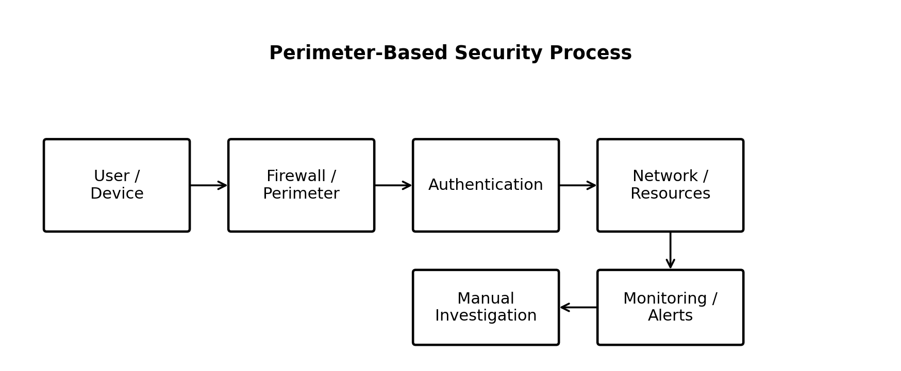
Figure 3.1: Model of the existing perimeter-based network-security process.
Figure 3.1 shows that the existing process places major trust decisions around the perimeter and authentication stages. Although monitoring and manual investigation provide useful security functions, the model does not inherently provide continuous trust reassessment or an automatic connection between anomalous behaviour and preventive action. This weakness is consistent with findings that traditional perimeter approaches and some existing Zero Trust implementations do not fully integrate intelligent anomaly detection and automated response (He et al., 2022; Alalmaie et al., 2024).
3.2.2 Architecture of the Existing System
The existing architecture is composed conceptually of users and devices, a network boundary, authentication services, internal resources, monitoring mechanisms, and security administrators. The firewall or perimeter control acts as the primary gatekeeper, while authentication determines whether a user can enter the protected environment. Once access has been established, monitoring systems may inspect traffic or system events and produce alerts for administrative review (He et al., 2022; Syed et al., 2022).
The architecture creates a separation between access control, monitoring, detection, and response. This separation can make it difficult to apply the security principle that trust should be continuously evaluated throughout a session. Zero Trust research instead advocates continuous verification and dynamic access decisions based on identity, device state, context, and observed behaviour (Syed et al., 2022; Kang et al., 2023).
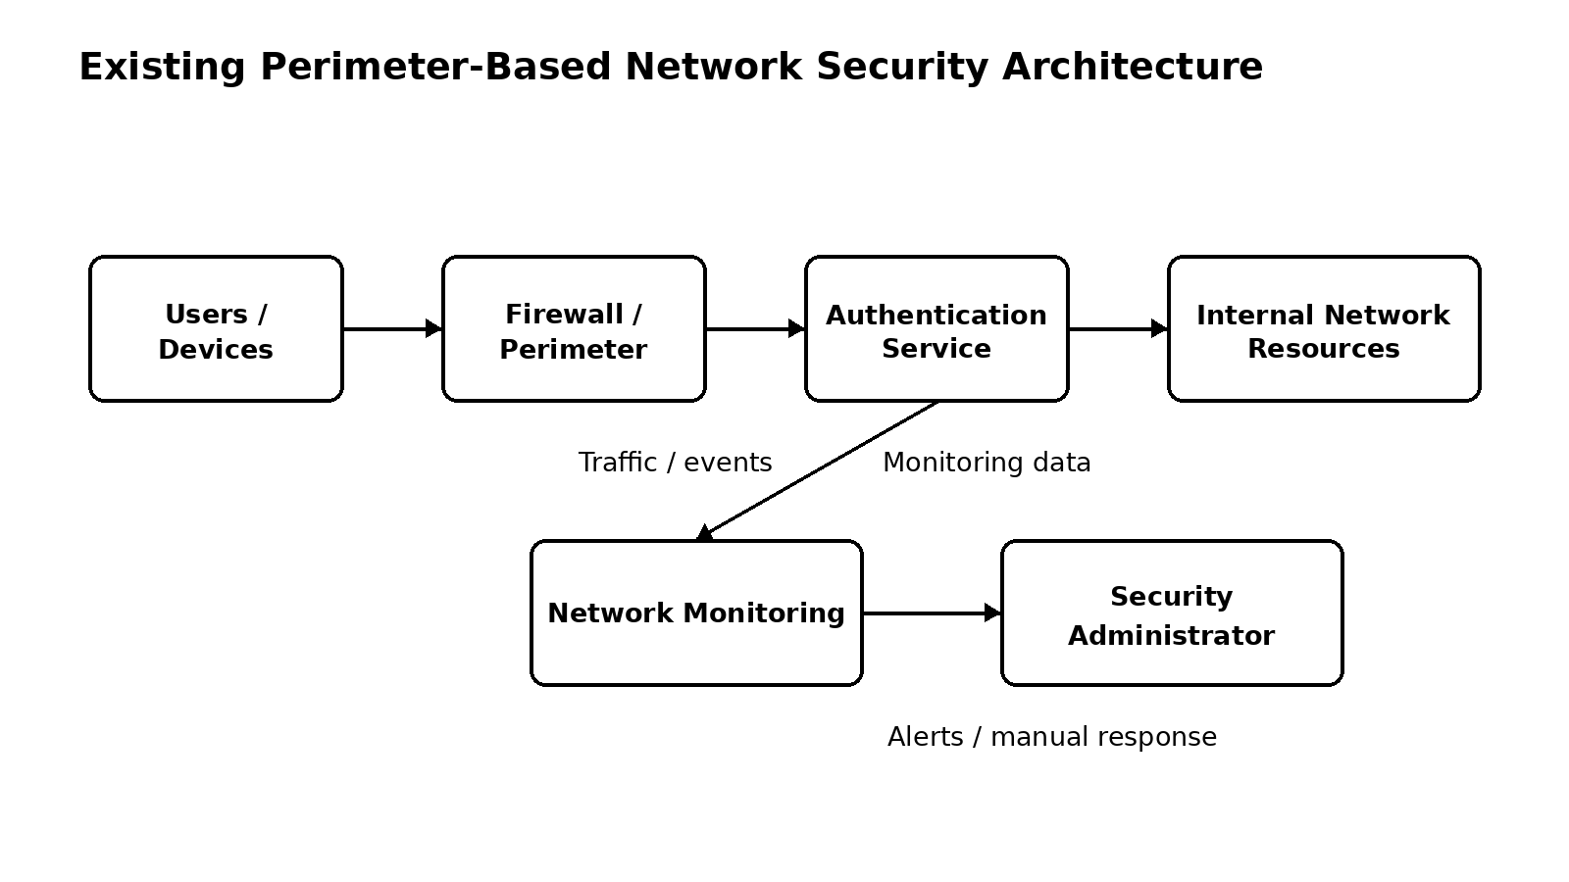
Figure 3.2: Architecture of the existing perimeter-based network-security system.
3.2.3 Weaknesses of the Existing System
Table 3.2: Weaknesses identified in the existing system.
Weakness | Description
Implicit trust after authentication | A successful authentication event may result in continued access without sufficient behavioural reassessment, creating opportunities for compromised legitimate accounts to be misused (He et al., 2022; Syed et al., 2022).
Dependence on known signatures | Traditional detection mechanisms can struggle with previously unseen or behaviourally novel attacks because they rely heavily on predefined patterns (Verkerken et al., 2022; Campazas-Vega et al., 2023).
Limited integration | Access control, monitoring, anomaly detection and response may operate as separate functions instead of one coordinated security pipeline (Alalmaie et al., 2024; Gambo & Almulhem, 2025).
Manual response delays | Human investigation can delay preventive action when security alerts are numerous or rapidly generated (Cao et al., 2024).
Lateral-movement exposure | If an attacker obtains valid access, insufficient segmentation and least-privilege controls can increase the opportunity for movement across resources (Dhiman et al., 2024).
False-positive burden | Anomaly-based systems may generate alerts for legitimate unusual behaviour, making appropriate model validation and threshold selection important (Maseer et al., 2024).
3.3 Analysis of the Proposed System
The proposed system was designed to address the weaknesses identified in the existing arrangement by integrating Zero Trust controls, continuous network monitoring, machine-learning-based anomaly detection, and automated threat prevention within a single framework. The central design principle is that no user or device should receive permanent implicit trust and that observed network behaviour should contribute to ongoing security decisions (Syed et al., 2022; Kang et al., 2023).
The proposed framework was structured so that identity and device information are evaluated before access, network activity is continuously observed during access, anomalous behaviour is identified through the detection component, and the resulting risk level is passed to a policy and response layer. This design follows the identified research gap, where existing works often provide either strong Zero Trust access control, intelligent detection, or automation without combining all three capabilities into one enterprise-oriented framework (Alalmaie et al., 2023; Alalmaie et al., 2024; Gambo & Almulhem, 2025).
The framework also adopts least-privilege access and segmentation as containment mechanisms. These controls are intended to reduce the amount of network access available to a user or device and to limit the consequences of a compromised account. Literature on Zero Trust identifies least privilege, continuous verification, and segmentation as important mechanisms for reducing unauthorised access and lateral movement (Dhiman et al., 2024; Syed et al., 2022).
3.3.1 Model of the Proposed System
The proposed model begins with a user or device requesting access to a protected resource. Identity and device information are evaluated by the Zero Trust policy component, after which authorised communication is subjected to continuous network monitoring. Network-flow or event features are processed by the anomaly-detection component, which produces a risk decision. The risk decision is then evaluated against security policies to determine whether normal access should continue, additional verification should be requested, access should be restricted, or a preventive action should be initiated. This sequence reflects the combination of continuous verification and intelligent monitoring advocated in recent Zero Trust and intrusion-detection research (Syed et al., 2022; Campazas-Vega et al., 2023; Cao et al., 2024).
3.3.2 Description of Major Components
User and Device Layer: Represents human users and network-connected devices requesting access to protected resources. The component supplies identity and device attributes required for trust evaluation, consistent with Zero Trust's continuous verification principle (Syed et al., 2022).
Identity and Device Verification: Validates user identity and device-related security conditions before access is granted and supports subsequent trust reassessment. Continuous verification is a central principle of Zero Trust security (He et al., 2022; Kang et al., 2023).
Policy Decision and Access Control: Evaluates identity, device status, requested resource and security conditions to determine the permitted level of access. Least privilege is used to limit users and devices to the resources required for legitimate activities (Dhiman et al., 2024).
Network Monitoring and Preprocessing: Collects relevant network events or flow information, cleans the input and transforms selected features into a form suitable for anomaly analysis. Network-flow analysis is widely used for identifying malicious behaviour and abnormal traffic patterns (Campazas-Vega et al., 2023; Verkerken et al., 2022).
Machine-Learning Anomaly Detection: Analyses prepared network features and identifies behaviour that differs from the learned or established normal pattern. Machine learning and deep learning approaches have demonstrated value for detecting complex and previously unseen network threats (Ahmad et al., 2021; Umer et al., 2022).
Risk and Policy Engine: Combines detection outcomes with predefined security conditions to classify the security state of an observed event or session. This creates a bridge between anomaly detection and Zero Trust access decisions (Alalmaie et al., 2024).
Automated Threat Prevention: Executes predefined protective actions when the security policy identifies unacceptable risk. Automation can reduce response delay and improve consistency of policy enforcement (Cao et al., 2024).
Logging and Audit: Records authentication events, monitoring events, anomaly decisions and response actions for later review and accountability. Continuous visibility and monitoring support effective Zero Trust enforcement and security administration (Syed et al., 2022; Kang et al., 2023).
3.3.3 Flowchart of the Proposed System
The proposed flow begins when a user or device requests access to a network resource. The request is first subjected to identity and device verification. If the security conditions are not satisfied, access is denied or restricted. If the conditions are satisfied, the request is evaluated against least-privilege policy before resource access is provided. Network behaviour is then continuously monitored and passed to the anomaly-detection component. A normal result allows the session to continue subject to policy, while an anomalous result triggers risk evaluation and the appropriate automated prevention action. This continuous loop is consistent with Zero Trust principles and intelligent anomaly-detection approaches described in the literature (Syed et al., 2022; Campazas-Vega et al., 2023).
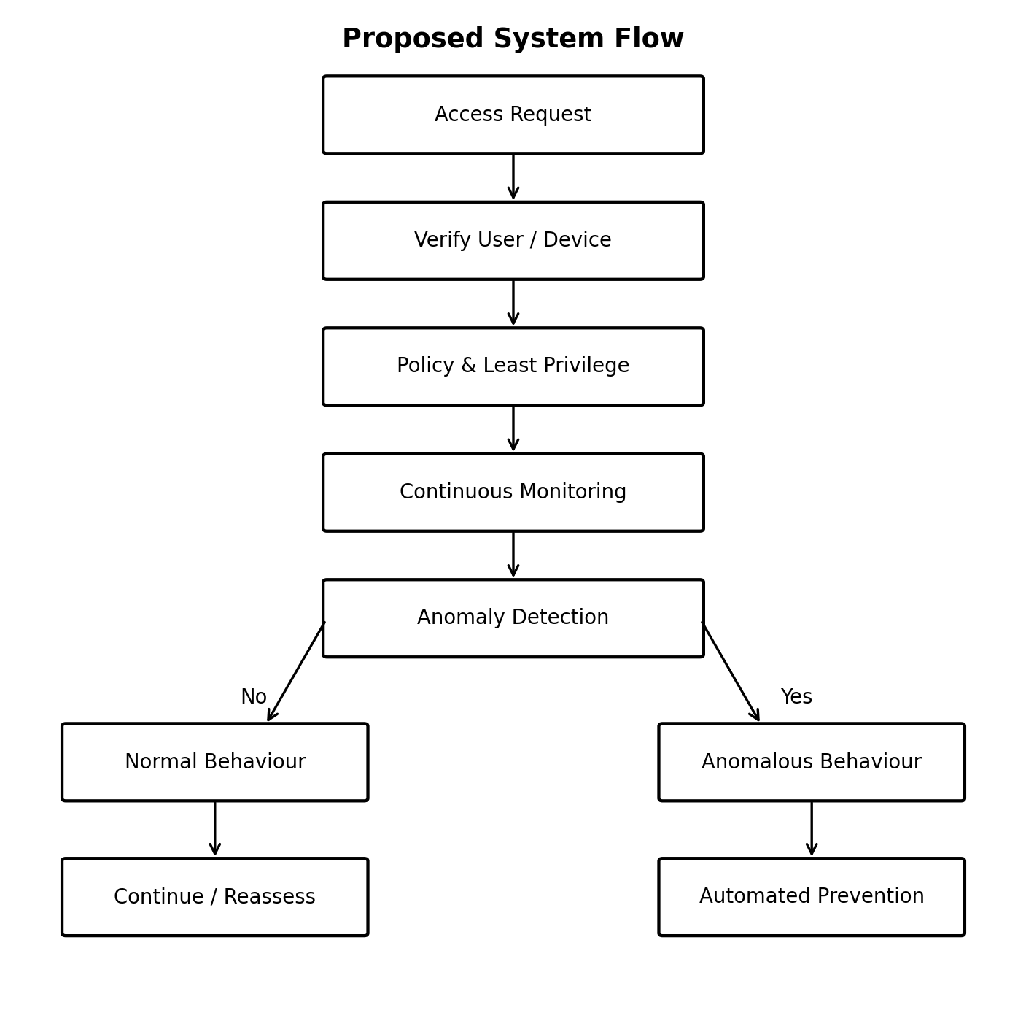
Figure 3.3: Flowchart of the proposed Zero-Trust monitoring and response process.
The flowchart in Figure 3.3 shows that access control and monitoring are not treated as separate security activities. Instead, access is continuously reassessed using behavioural evidence, and anomalous behaviour is connected to an automated prevention path. Such integration is intended to reduce the gap between detecting a threat and enforcing a security response, which is one of the limitations identified in previous Zero Trust and automation studies (Alalmaie et al., 2024; Cao et al., 2024).
3.3.4 Sequence of the Proposed System
The sequence of interactions begins with the user or device sending an access request to the policy layer. The policy layer requests identity and device verification, receives the verification outcome, and determines whether the requested resource can be accessed. Once access is permitted, monitoring begins or continues, network events are processed, and the anomaly detector returns a classification or risk indication. Where the behaviour is suspicious, the policy engine invokes an automated prevention action and records the event; otherwise, the session continues under continuous monitoring. This sequence combines the continuous verification principle of Zero Trust with the detection and response capabilities supported by machine-learning security research (Syed et al., 2022; Maseer et al., 2024).
Table 3.3: Sequence of interactions in the proposed system.
Step | Actor/Component | Interaction | Outcome
1 | User/Device | Sends access request | Request received
2 | Verification | Validates identity/device attributes | Trust context produced
3 | Policy Engine | Checks least-privilege rules | Allow, restrict or deny
4 | Monitor | Collects network event/flow information | Monitoring record produced
5 | Anomaly Detector | Analyses selected features | Normal/anomalous result
6 | Risk/Policy Engine | Evaluates result against policy | Response decision
7 | Prevention | Blocks, isolates, restricts or requests verification when required | Threat contained
8 | Audit | Records event and action | Security trail maintained
3.4 System Requirements
The system requirements were derived from the objectives of the study and the weaknesses identified in the existing security process. The requirements separate the functions that the proposed framework must perform from quality attributes such as security, performance, usability and scalability. This separation follows the Faculty of Computing project guide, which requires functional and non-functional requirements to be stated separately and unambiguously (Faculty Quality Assurance Committee, 2026).
The requirements also reflect the security capabilities identified in the literature. Zero Trust requires continuous verification and least-privilege access, while intelligent intrusion detection requires appropriate monitoring, data processing and anomaly analysis. Automated response additionally requires a mechanism for connecting detection decisions to enforceable security actions (Syed et al., 2022; Ahmad et al., 2021; Cao et al., 2024).
3.4.1 Functional Requirements
FR1: The system shall authenticate and verify users requesting access to protected network resources. These functions are consistent with the continuous-verification, monitoring, anomaly-detection and automated-response capabilities identified in the reviewed literature (Syed et al., 2022; Campazas-Vega et al., 2023; Cao et al., 2024).
FR2: The system shall evaluate the security status of connected devices before granting or maintaining access. These functions are consistent with the continuous-verification, monitoring, anomaly-detection and automated-response capabilities identified in the reviewed literature (Syed et al., 2022; Campazas-Vega et al., 2023; Cao et al., 2024).
FR3: The system shall apply least-privilege access policies to users and devices. These functions are consistent with the continuous-verification, monitoring, anomaly-detection and automated-response capabilities identified in the reviewed literature (Syed et al., 2022; Campazas-Vega et al., 2023; Cao et al., 2024).
FR4: The system shall continuously monitor relevant network traffic and security events. These functions are consistent with the continuous-verification, monitoring, anomaly-detection and automated-response capabilities identified in the reviewed literature (Syed et al., 2022; Campazas-Vega et al., 2023; Cao et al., 2024).
FR5: The system shall preprocess selected network observations for anomaly analysis. These functions are consistent with the continuous-verification, monitoring, anomaly-detection and automated-response capabilities identified in the reviewed literature (Syed et al., 2022; Campazas-Vega et al., 2023; Cao et al., 2024).
FR6: The system shall classify observed network behaviour as normal or anomalous using the selected machine-learning model. These functions are consistent with the continuous-verification, monitoring, anomaly-detection and automated-response capabilities identified in the reviewed literature (Syed et al., 2022; Campazas-Vega et al., 2023; Cao et al., 2024).
FR7: The system shall assign or derive a security risk decision from anomaly-detection outcomes and policy conditions. These functions are consistent with the continuous-verification, monitoring, anomaly-detection and automated-response capabilities identified in the reviewed literature (Syed et al., 2022; Campazas-Vega et al., 2023; Cao et al., 2024).
FR8: The system shall automatically apply predefined preventive actions to detected high-risk activities. These functions are consistent with the continuous-verification, monitoring, anomaly-detection and automated-response capabilities identified in the reviewed literature (Syed et al., 2022; Campazas-Vega et al., 2023; Cao et al., 2024).
FR9: The system shall record authentication, monitoring, detection and response events for audit purposes. These functions are consistent with the continuous-verification, monitoring, anomaly-detection and automated-response capabilities identified in the reviewed literature (Syed et al., 2022; Campazas-Vega et al., 2023; Cao et al., 2024).
FR10: The system shall support security administrators in reviewing detected events and system decisions. These functions are consistent with the continuous-verification, monitoring, anomaly-detection and automated-response capabilities identified in the reviewed literature (Syed et al., 2022; Campazas-Vega et al., 2023; Cao et al., 2024).
3.4.2 Non-Functional Requirements
Table 3.4: Non-functional requirements of the proposed system.
Requirement | Specification
Security | The system should enforce authentication, least privilege, access policies and auditable security decisions to reduce unauthorised access (Syed et al., 2022; Dhiman et al., 2024).
Performance | The monitoring and detection pipeline should process security observations within a practical response interval so that detected threats can be acted upon promptly (Cao et al., 2024).
Accuracy | The anomaly-detection component should achieve an acceptable balance among precision, recall, false positives and false negatives, because model quality directly affects operational usefulness (Maseer et al., 2024).
Scalability | The framework should allow additional users, devices and network events to be incorporated without requiring a complete redesign of the security architecture (Kang et al., 2023).
Reliability | The monitoring and logging functions should remain dependable enough to support continuous security visibility and incident investigation (Syed et al., 2022).
Usability | Administrative outputs should be understandable enough for security personnel to interpret detection outcomes and response actions without unnecessary complexity (Pawlicki et al., 2024).
Maintainability | The framework should allow policy rules, detection models and response actions to be updated as threat patterns and organisational requirements change (Gambo & Almulhem, 2025).
3.5 System Design (Models)
The system design translates the identified requirements into models that describe actors, processes, interactions and structural relationships. The models were selected to provide a consistent representation of how the Zero Trust controls, monitoring component, anomaly detector, policy engine and automated prevention component interact. The Faculty of Computing guide requires appropriate use-case, activity, sequence, class and flow models, with each model captioned and explained (Faculty Quality Assurance Committee, 2026).
3.5.1 Use-Case Model
The main actors in the proposed framework are the network user or device and the security administrator. The user or device initiates access requests and generates network activity, while the security administrator reviews events, manages policies and responds to administrative notifications. The system itself performs authentication, device verification, policy evaluation, monitoring, anomaly detection, automated prevention and logging. This division reflects the principle that Zero Trust security decisions should be policy-driven and continuously informed by security observations (Syed et al., 2022; Kang et al., 2023).
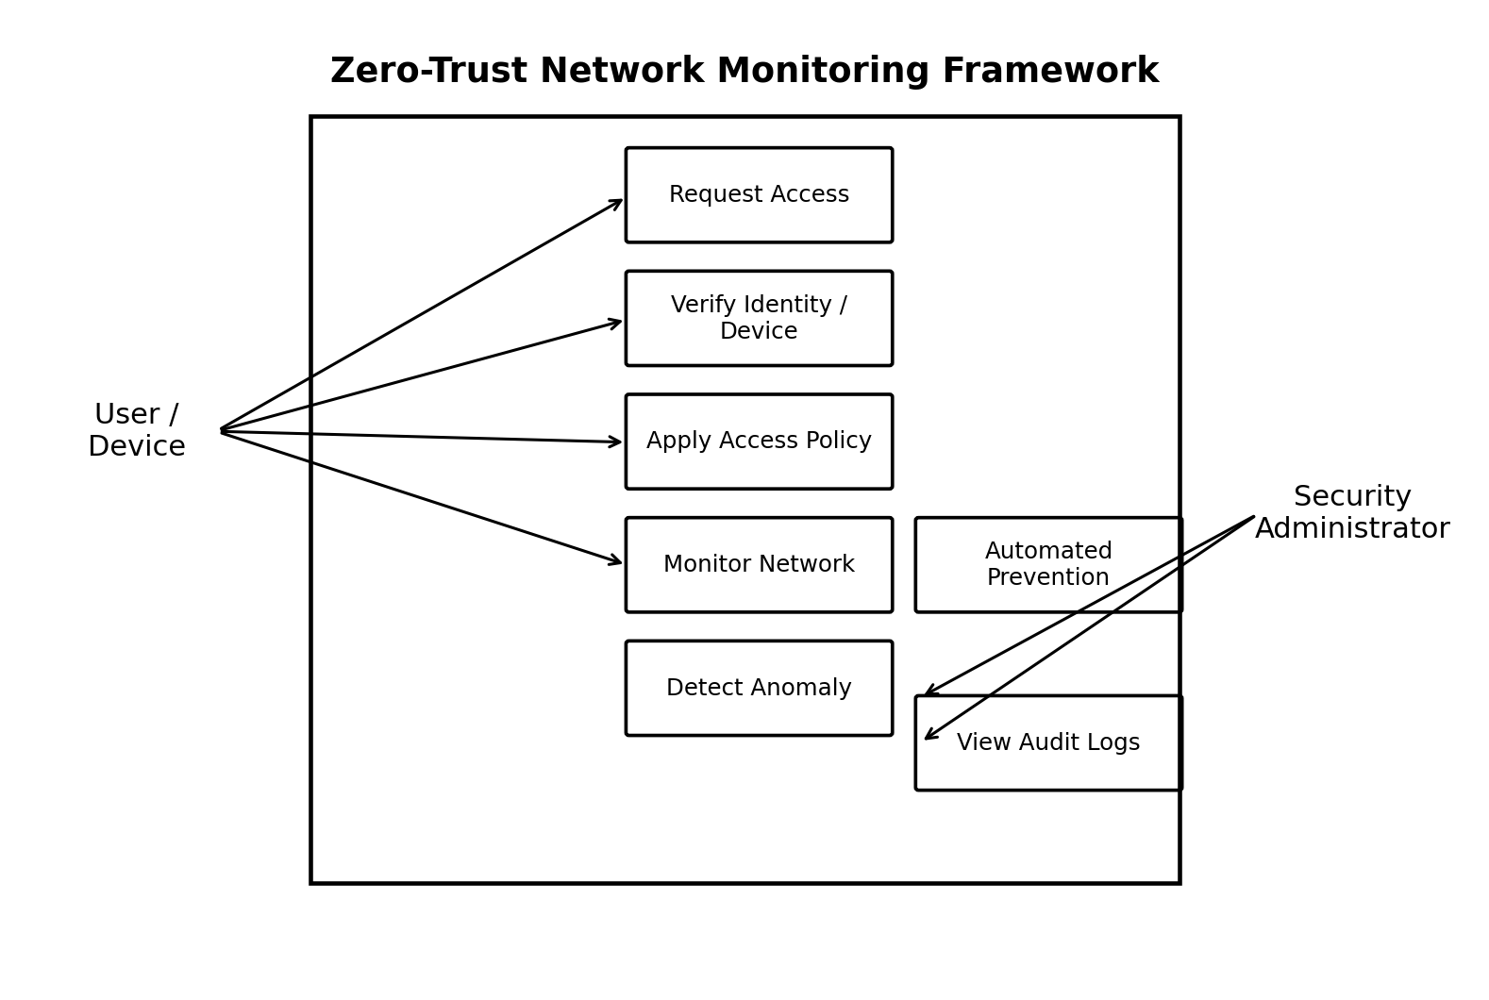
Figure 3.4: Use-case model of the proposed framework.
Figure 3.4 indicates that the framework automates the security functions that are most sensitive to response delay while retaining an administrative role for policy and audit management. This arrangement supports the literature's emphasis on combining continuous verification, intelligent detection and automated response rather than treating these capabilities as isolated mechanisms (Alalmaie et al., 2024; Cao et al., 2024).
3.5.2 Activity Model
The activity model describes the operational path from access request to security decision. The activity begins with a request, proceeds through verification and policy evaluation, and then enters continuous monitoring. The anomaly-detection result determines whether the normal path continues or whether a preventive action is required. This model supports the intended objective of continuously monitoring network activities and restricting suspicious behaviour in real time (Campazas-Vega et al., 2023; Gambo & Almulhem, 2025).
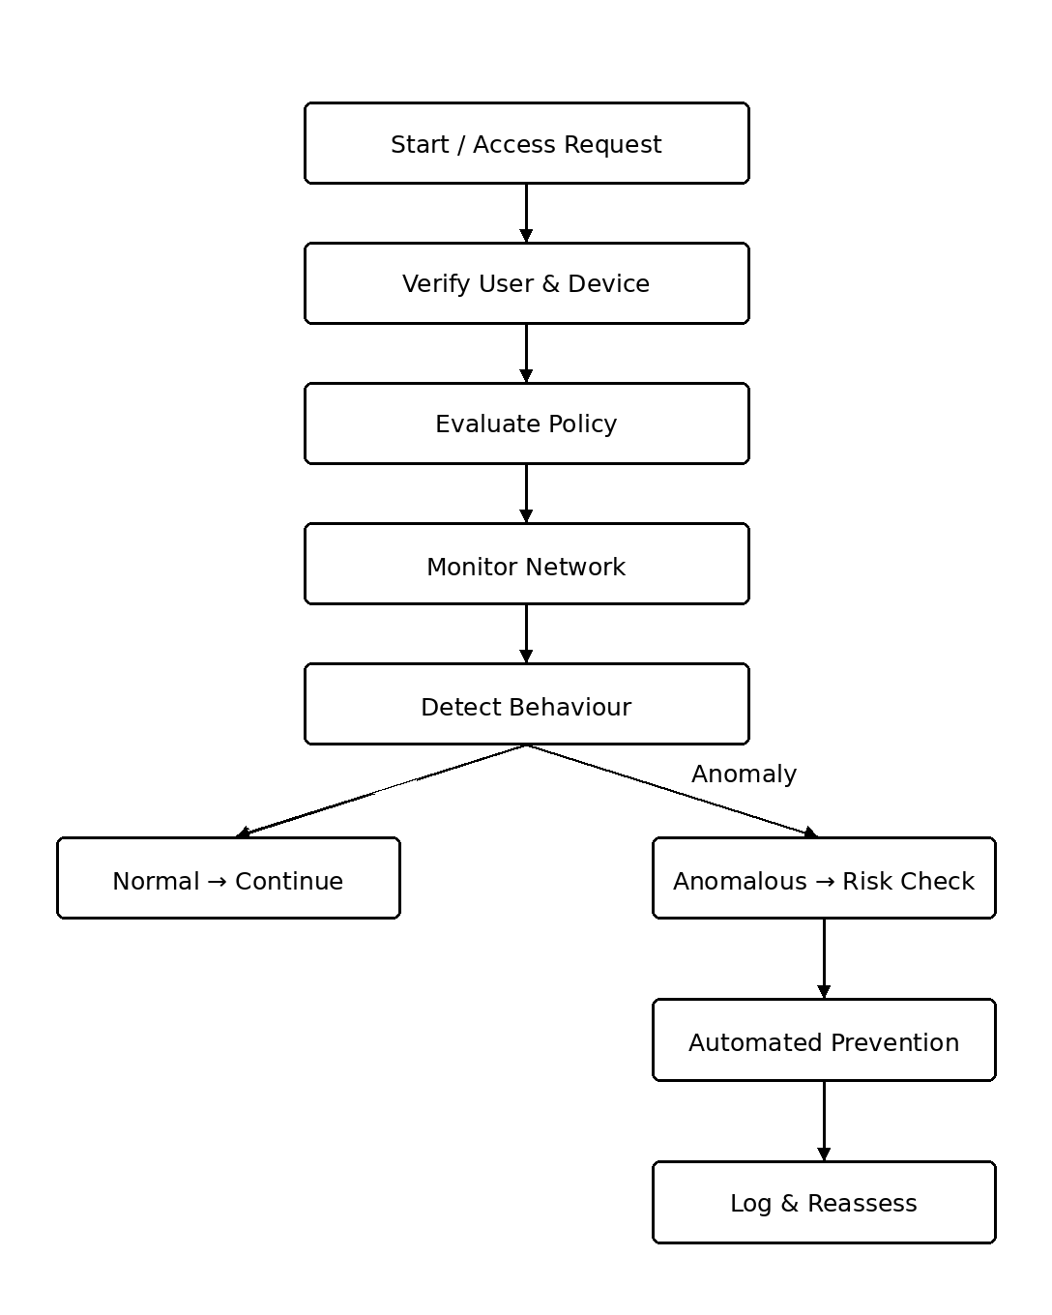
Figure 3.5: Activity model of the proposed security process.
The activity model demonstrates the continuous nature of the security process. A normal classification does not terminate security evaluation; rather, monitoring continues so that a later change in behaviour can influence the trust decision. This reflects the Zero Trust requirement that trust should not be treated as permanent and that security decisions should be continuously reassessed (Syed et al., 2022; He et al., 2022).
3.5.3 Sequence Diagram
The sequence design establishes the order of communication among the user or device, verification service, policy engine, monitoring module, anomaly detector and automated prevention module. The order is important because detection results must be available to the policy engine before a preventive decision can be enforced. Integrating these interactions addresses the limitation identified in previous work where Zero Trust access control and intelligent detection were frequently implemented as separate functions (Alalmaie et al., 2023; Alalmaie et al., 2024).
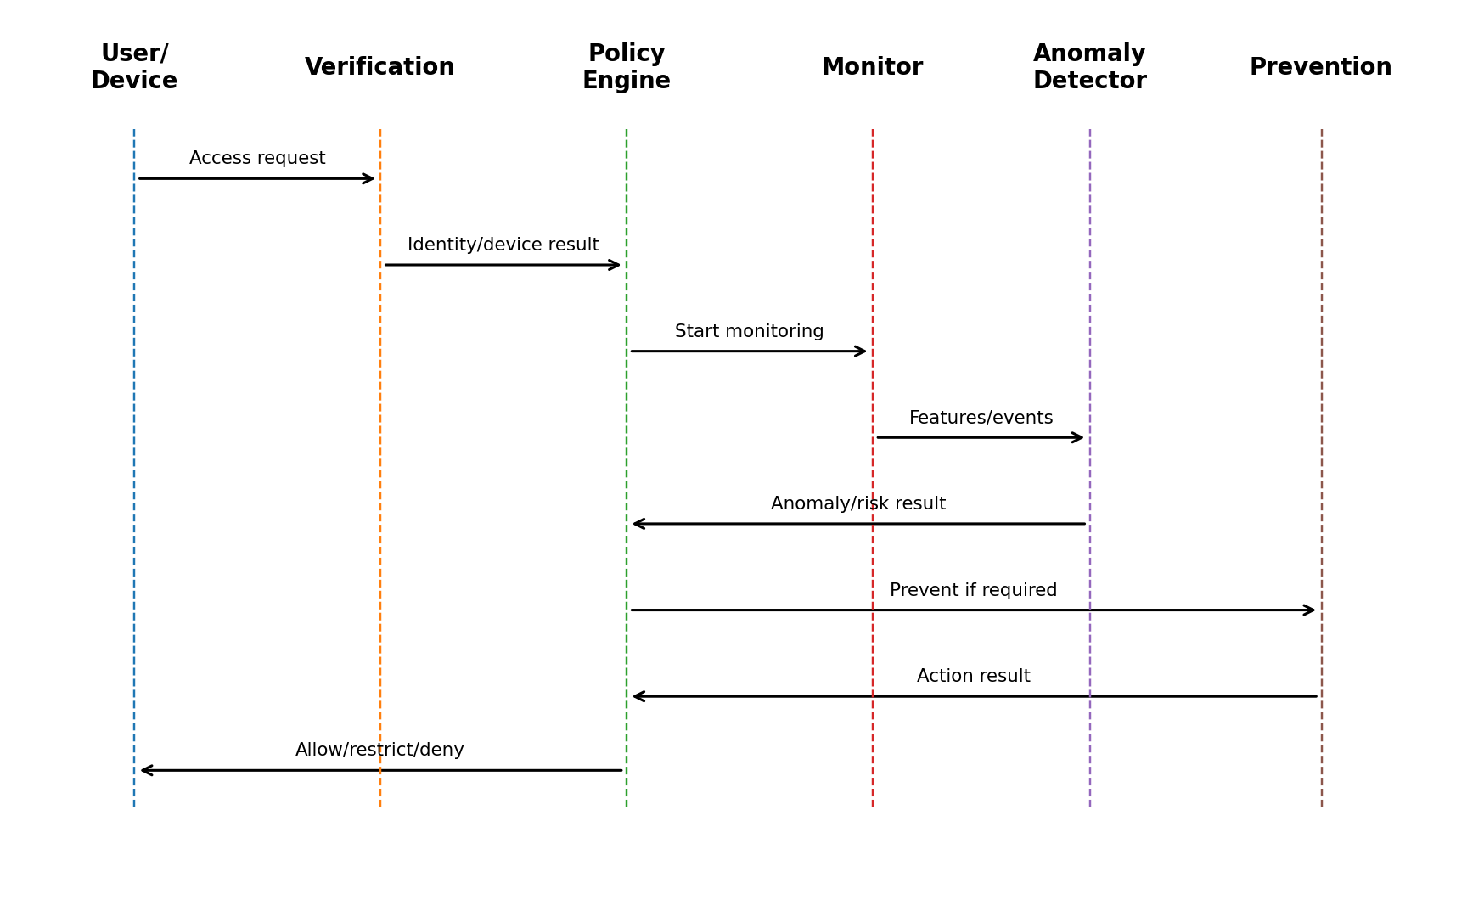
Figure 3.6: Sequence diagram of the proposed framework.
Figure 3.6 shows the interaction sequence through which a security event moves from an access request to a policy decision and, where necessary, an automated response. The design ensures that monitoring and anomaly results can influence access decisions after authentication rather than treating successful authentication as permanent trust. This is consistent with Zero Trust research on continuous authentication, dynamic trust evaluation and behavioural monitoring (Syed et al., 2022; Kang et al., 2023).
3.5.4 Class Model
The class model represents the principal data and service entities required by the framework. The major entities are User, Device, AccessRequest, NetworkEvent, AnomalyResult, SecurityPolicy, ResponseAction and AuditLog. These entities provide a logical structure for storing identity information, device information, access requests, network observations, detection outcomes, policy rules and automated actions. Separating these responsibilities supports maintainability and provides a basis for traceable security auditing (Syed et al., 2022; Maseer et al., 2024).
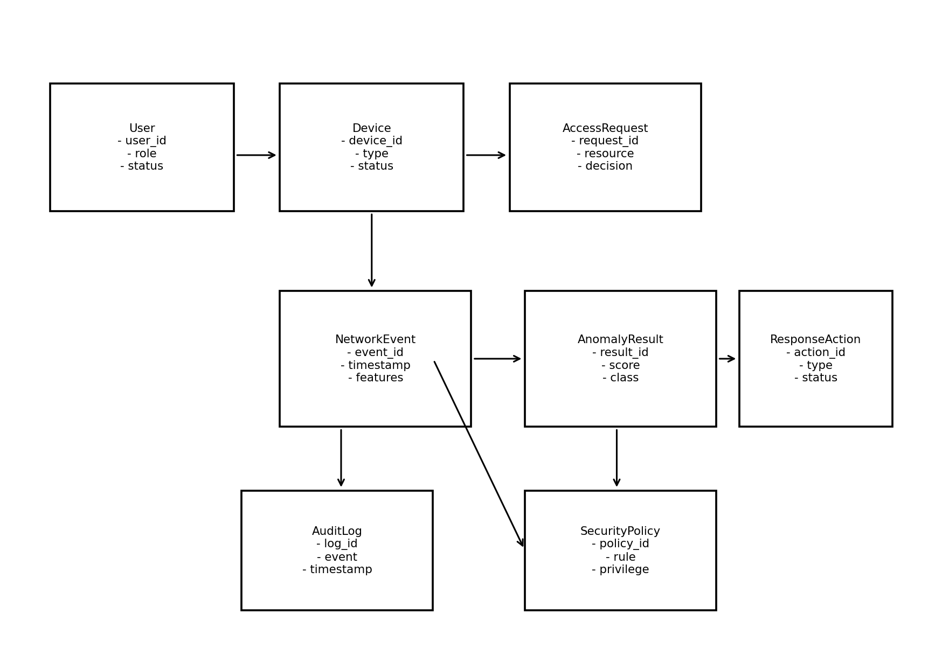
Figure 3.7: Class model of the proposed framework.
The class model separates identity, device, access, network-observation, detection, policy, response and audit responsibilities. This separation is intended to support clear traceability from a detected network event to the policy decision and response action associated with that event. Such traceability is important for an adaptive security framework because anomaly detection must be connected to enforceable security decisions rather than existing only as an alert-generation mechanism (Cao et al., 2024; Gambo & Almulhem, 2025).
3.5.5 Data-Flow Model
The data-flow model focuses on how security information moves through the proposed framework. User and device information enter the verification process, network observations enter the monitoring and preprocessing process, prepared features are passed to anomaly detection, and detection outcomes are supplied to the policy and response layer. Audit information is then stored for later review. This flow supports the requirement for continuous visibility and provides the data pathway required for machine-learning-based anomaly detection (Campazas-Vega et al., 2023; Maseer et al., 2024).
3.6 Database Design
The database was conceptually designed to store the identity, device, access, network-event, anomaly, policy, response and audit information required by the framework. The design separates related data into logical entities to reduce duplication and maintain relationships among security events. This approach is important for a monitoring framework because detection decisions and preventive actions should remain traceable to the network observation and policy context that produced them (Maseer et al., 2024; Syed et al., 2022).
The database design follows a normalised relational structure in which each major entity represents one security concern and related entities are connected through identifiers. User information is separated from device information, while network events are separated from anomaly results and response actions. This structure supports efficient retrieval and reduces unnecessary repetition when multiple network events are associated with the same device or user (Faculty Quality Assurance Committee, 2026).
3.6.1 Entity-Relationship Design
The principal relationships are defined so that one user may be associated with multiple devices and access requests, a device may generate multiple network events, a network event may produce an anomaly result, and an anomaly result may trigger a response action according to the applicable security policy. Audit records provide a historical relationship between events and actions. These relationships support the traceability required for security monitoring and incident analysis (Syed et al., 2022; Cao et al., 2024).
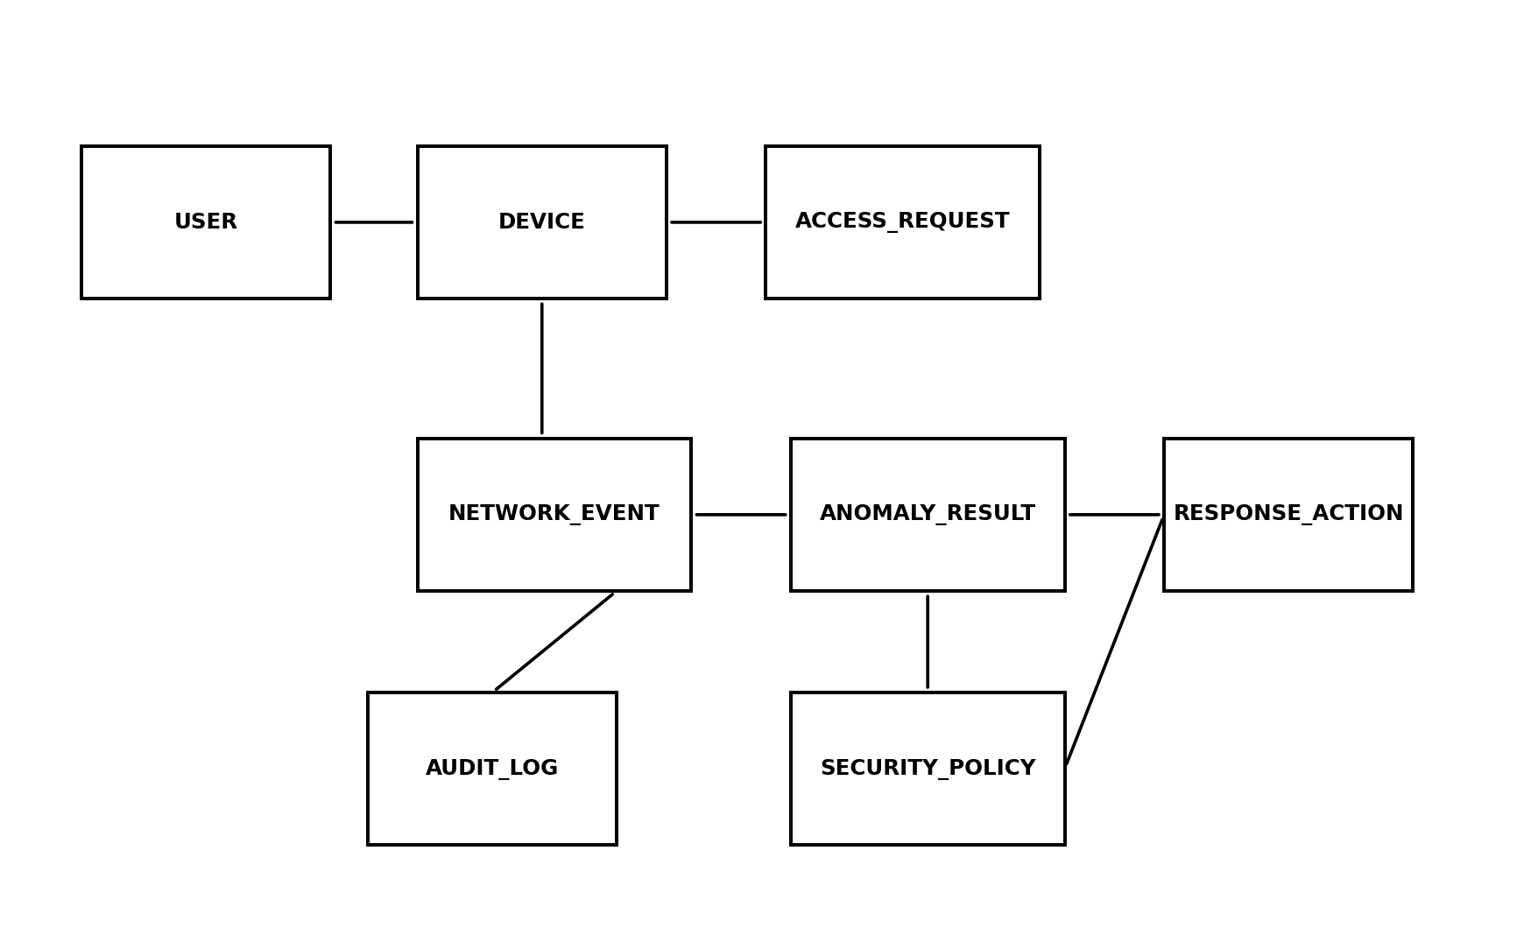
Figure 3.8: Entity-relationship model of the proposed framework database.
Figure 3.8 provides the logical relationship among the main database entities. The separation of network events from anomaly results allows multiple analytical outcomes or model versions to be associated with observations without duplicating identity information, while the response and audit entities preserve evidence of the action taken. This arrangement supports the accountability and continuous-monitoring requirements of the proposed framework (Syed et al., 2022; Maseer et al., 2024).
3.6.2 Normalised Database Schema
Table 3.5: Normalised database schema.
Entity | Normalised Schema
USER | user_id (PK), role, username, status, created_at
DEVICE | device_id (PK), user_id (FK), device_type, device_status, last_seen
ACCESS_REQUEST | request_id (PK), user_id (FK), device_id (FK), resource, decision, request_time
NETWORK_EVENT | event_id (PK), device_id (FK), timestamp, source, destination, protocol, features
ANOMALY_RESULT | result_id (PK), event_id (FK), model_name, anomaly_score, classification, detected_at
SECURITY_POLICY | policy_id (PK), policy_name, condition, privilege_level, action
RESPONSE_ACTION | action_id (PK), result_id (FK), policy_id (FK), action_type, status, executed_at
AUDIT_LOG | log_id (PK), user_id (FK), event_id (FK), action_id (FK), event_type, timestamp, details
3.6.3 Data Dictionary
The data dictionary defines the principal fields used by the proposed database. The selected fields are limited to information required for identity verification, access control, network monitoring, anomaly detection, policy enforcement and auditing. Keeping the data model focused supports maintainability while providing the traceability required by an integrated security framework (Faculty Quality Assurance Committee, 2026).
Table 3.6: Data dictionary of the proposed framework.
Field | Entity | Type | Constraint | Description
user_id | USER | INT | Primary key | Unique user identifier
role | USER | VARCHAR(50) | NOT NULL | Assigned user role
status | USER | VARCHAR(20) | NOT NULL | Current user status
device_id | DEVICE | INT | Primary key | Unique device identifier
user_id | DEVICE | INT | Foreign key | User associated with device
device_status | DEVICE | VARCHAR(20) | NOT NULL | Current device security status
request_id | ACCESS_REQUEST | INT | Primary key | Unique access request
decision | ACCESS_REQUEST | VARCHAR(20) | NOT NULL | Allow, restrict or deny decision
event_id | NETWORK_EVENT | INT | Primary key | Unique network event
timestamp | NETWORK_EVENT | DATETIME | NOT NULL | Time of network observation
protocol | NETWORK_EVENT | VARCHAR(20) | NOT NULL | Observed network protocol
result_id | ANOMALY_RESULT | INT | Primary key | Unique anomaly result
anomaly_score | ANOMALY_RESULT | DECIMAL | NOT NULL | Numerical anomaly/risk score
classification | ANOMALY_RESULT | VARCHAR(30) | NOT NULL | Normal or anomalous class
policy_id | SECURITY_POLICY | INT | Primary key | Unique security policy
privilege_level | SECURITY_POLICY | VARCHAR(30) | NOT NULL | Permitted access level
action_id | RESPONSE_ACTION | INT | Primary key | Unique response action
action_type | RESPONSE_ACTION | VARCHAR(50) | NOT NULL | Preventive action performed
log_id | AUDIT_LOG | INT | Primary key | Unique audit record
event_type | AUDIT_LOG | VARCHAR(50) | NOT NULL | Type of logged event
3.6.4 Database Security Considerations
Database security was considered as part of the overall Zero Trust design because security logs, identity information and detection outcomes can themselves represent sensitive organisational information. Access to stored records should therefore be controlled according to role and least-privilege principles, while audit records should be protected against unauthorised modification. These controls are consistent with the broader Zero Trust requirement for strict access control and continuous security monitoring (Syed et al., 2022; Dhiman et al., 2024).
The database should also support auditability by retaining timestamps and relationships among access requests, network events, anomaly decisions and response actions. Such traceability makes it possible to determine what event was observed, what decision was made and what action followed. Maintaining this relationship is particularly important when automated security actions are used because the system must provide evidence for later review and evaluation (Cao et al., 2024; Gambo & Almulhem, 2025).
3.7 System Architecture
The system architecture presents the components, layers, and interactions that operationalise the proposed framework. It brings together identity and device verification, policy-based access control, continuous network monitoring, machine-learning anomaly detection, risk evaluation, automated threat prevention, and audit logging. The architectural arrangement reflects the need to integrate Zero Trust controls with intelligent monitoring and automated response identified in the reviewed literature (Alalmaie et al., 2024; Cao et al., 2024; Gambo & Almulhem, 2025).
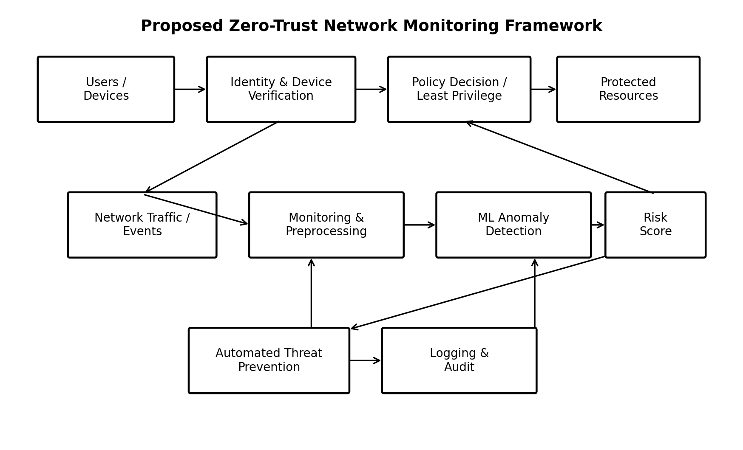
Figure 3.9: Proposed architecture of the Zero-Trust Network Monitoring Framework.
The architecture is designed so that trust decisions are continuously informed by identity, device condition, network behaviour, and security policy. Monitoring data are processed by the anomaly-detection component, while the resulting risk decision is supplied to the policy and response layers. Automated prevention provides rapid enforcement when defined security conditions are met, and audit logging maintains traceability of security events and actions (Syed et al., 2022; Maseer et al., 2024; Cao et al., 2024).
3.8 Summary of System Design
This chapter presented the Object-Oriented Analysis and Design Methodology (OOADM), the existing-system analysis, proposed-system analysis, requirements and system design for the Zero-Trust Network Monitoring Framework with Automated Threat Prevention and Anomaly Detection. OOADM was used to identify the system objects, actors, relationships, interactions and processes required to model the framework, while the resulting architecture, UML models and database design provide the foundation for implementation and evaluation (Alalmaie et al., 2023; Syed et al., 2022).
The existing-system analysis identified implicit trust after authentication, dependence on known signatures, separation of security functions, manual response delays and limited adaptive detection as important weaknesses. The proposed design addressed these limitations by combining continuous identity and device verification, least-privilege access, continuous monitoring, machine-learning-based anomaly detection, policy-driven risk evaluation, automated prevention and audit logging. These design choices directly respond to the research gap identified in Chapter Two (Alalmaie et al., 2024; Cao et al., 2024; Gambo & Almulhem, 2025).
The models and database design provide the engineering foundation for the implementation and evaluation presented in Chapter Four. The architecture, requirements, process models and data structures were designed to remain traceable to the objectives of the study and to the capabilities identified in the reviewed literature. The subsequent chapter therefore focuses on the development environment, implementation of the proposed modules, testing, results and performance evaluation, in accordance with the Faculty of Computing project guide (Faculty Quality Assurance Committee, 2026).

CHAPTER FOUR
SYSTEM IMPLEMENTATION, TESTING, AND RESULTS
This chapter presents the implementation structure, testing procedure, documentation approach, and evaluation framework for the proposed Zero-Trust Network Monitoring Framework with Automated Threat Prevention and Anomaly Detection. The implementation follows the OOADM design presented in Chapter Three, where identity and device verification, policy evaluation, network monitoring, anomaly detection, automated prevention, and audit logging were defined as interacting system components (Alalmaie et al., 2023; Syed et al., 2022).
The Faculty of Computing guide requires Chapter Four to demonstrate how the designed system is implemented, tested, and evaluated, with implementation details linked to the requirements and architecture established earlier. In keeping with that requirement, the sections below follow the approved sequence of development environment and tools, implementation, user-interface design, testing, system documentation, results and performance evaluation, and discussion of results (Faculty Quality Assurance Committee, 2026).
4.1 Development Environment and Tools
The implementation environment is organised around a Python-based security-processing workflow because the proposed framework requires network-event processing, feature preparation, anomaly analysis, policy evaluation, and automated response logic. Python is suitable for this type of workflow because machine-learning and data-processing libraries can be combined with security-monitoring components in a modular implementation (Ahmad et al., 2021; Maseer et al., 2024).
The implementation is divided into a monitoring layer, a detection layer, a policy layer, a response layer, and a persistence layer. This arrangement follows the architecture and class responsibilities defined in Chapter Three and makes each component easier to test independently before the complete pipeline is evaluated (Alalmaie et al., 2023; Cao et al., 2024).
Table 4.1: Development environment and major implementation tools.
Tool/Technology | Purpose in the Proposed System | Reason for Selection
Python | Core implementation language for monitoring, preprocessing, detection and policy logic | Supports modular security and machine-learning development (Ahmad et al., 2021).
Pandas/NumPy | Data preparation, feature handling and numerical processing | Supports structured processing of network-event data required by anomaly detection (Maseer et al., 2024).
Machine-learning library | Training and applying the selected anomaly-detection model | Provides practical model-development facilities for network anomaly analysis (Umer et al., 2022).
Relational database | Stores users, devices, network events, anomaly results, policies, responses and audit records | Supports traceability and structured storage of security events (Syed et al., 2022).
Network monitoring component | Captures or receives relevant network-flow/event information | Provides the continuous visibility required by the framework (Kang et al., 2023).
Exact software-version numbers should be recorded from the actual implementation environment before submission. The supplied project files did not contain an executable environment manifest, dependency file, or terminal output from which exact versions could be verified; therefore, no unverified version number is presented here. This avoids introducing unsupported implementation facts into the report (Faculty Quality Assurance Committee, 2026).
4.2 System Implementation
The system implementation follows the component structure established in Chapter Three. The first module is the User and Device module, which receives access requests and provides the identity and device attributes required for security evaluation. The second module is the Policy Decision and Access Control module, which applies authentication, authorization and least-privilege rules before access is maintained (Syed et al., 2022; Dhiman et al., 2024).
The Network Monitoring and Preprocessing module receives network-flow or event information and prepares relevant features for analysis. The Machine-Learning Anomaly Detection module then classifies the observed behaviour as normal or anomalous. This arrangement follows the literature showing that network-flow features and intelligent learning techniques can improve the detection of behaviour that differs from established normal patterns (Campazas-Vega et al., 2023; Ahmad et al., 2021).
The Risk and Policy Engine connects the anomaly result to a security decision. When the observed event satisfies a high-risk condition, the Automated Threat Prevention module can apply the corresponding policy action, such as restricting access or isolating the affected activity. The Logging and Audit module records the event, decision and response so that the security administrator can review what occurred and why the action was taken (Cao et al., 2024; Gambo & Almulhem, 2025).
The implementation therefore follows a simple processing path: receive request or network event, verify identity and device context, evaluate policy, monitor activity, prepare features, detect behaviour, evaluate risk, apply a response where necessary, and record the outcome. The sequence maintains the continuous-verification principle of Zero Trust instead of treating successful authentication as permanent trust (He et al., 2022; Kang et al., 2023).
Table 4.2: Implemented system modules and their design relationships.
Module | Main Function | Related Chapter Three Design
Identity and Device Verification | Checks identity and device security conditions | Policy and access-control model
Policy Decision and Access Control | Allows, restricts or denies access using security rules | Use-case, sequence and class models
Network Monitoring and Preprocessing | Collects and prepares network observations | Architecture and flowchart
Anomaly Detection | Classifies network behaviour as normal or anomalous | Activity and data-flow models
Risk and Policy Engine | Converts detection results into security decisions | Sequence and class models
Automated Threat Prevention | Applies predefined protective action | Architecture and activity model
Logging and Audit | Stores security events and response records | Database and ER design
The modular structure is important because each component has a defined responsibility and can be checked independently. This reflects the object-oriented design principle used in Chapter Three and supports maintainability when detection models, security policies or response rules need to be changed (Alalmaie et al., 2023; Maseer et al., 2024).
For maintainability, the implementation should keep security policies separate from the anomaly-detection model. This allows a policy rule to be changed without retraining the detection component and allows the detection model to be evaluated or replaced without redesigning the database and access-control structure. Such separation is consistent with the object-oriented organisation adopted for the proposed framework (Alalmaie et al., 2023; Cao et al., 2024).
A simple implementation workflow can therefore be explained as five understandable stages: collect, verify, detect, decide and record. The system first collects a request or network event, verifies the relevant identity and device context, detects whether the behaviour is normal or anomalous, decides what policy action is appropriate, and records the result. This workflow mirrors the activity and sequence models presented in Chapter Three (Kang et al., 2023; Alalmaie et al., 2023).
The database implementation follows the normalised structure defined in Chapter Three. User records are separated from device records, access requests are separated from network events, and anomaly results are connected to the event that produced them. Response actions are linked to both the anomaly result and the applicable policy, while audit records preserve the history of important security decisions (Syed et al., 2022; Maseer et al., 2024).
The automated-prevention stage is deliberately policy-driven. A detection result does not by itself determine the final action; the risk and policy engine checks the result against configured security conditions. Depending on the policy, the system can continue the session, restrict access, request additional verification, or initiate a predefined preventive action. This separation reduces the possibility of applying an inappropriate response to every unusual event (Cao et al., 2024; Gambo & Almulhem, 2025).
The anomaly-detection stage receives the prepared network observations from the monitoring and preprocessing module. The selected features are passed to the detection component, which produces a classification or anomaly score. The result is then returned to the risk and policy engine rather than being treated as an isolated alert. This preserves the relationship between network behaviour and the Zero Trust decision process (Campazas-Vega et al., 2023; Maseer et al., 2024).
4.3 User-Interface Design
The proposed framework is primarily a security-monitoring and control system rather than a conventional public-facing application. Its administrative interface should therefore present security information in a form that allows an authorised administrator to understand access decisions, current network events, anomaly classifications, policy actions and audit records without unnecessary complexity (Pawlicki et al., 2024; Syed et al., 2022).
The main administrative views are derived directly from the database and class models in Chapter Three. A monitoring view should show recent network events and their current classification; an access-control view should show users, devices and decisions; an alert or anomaly view should show the detected classification and risk state; and an audit view should show the relationship between an event, policy decision and response action. These views support traceability and continuous visibility (Kang et al., 2023; Cao et al., 2024).
Actual interface screenshots should be taken from the executed implementation and inserted here before final submission. No genuine implementation screenshots were present in the supplied project materials, so fabricated screenshots have not been inserted. This is necessary because the project guide requires implementation evidence and explicitly prohibits fabricated results or evidence (Faculty Quality Assurance Committee, 2026).
4.4 System Testing
Testing is organised around the functional requirements in Chapter Three. Unit-level checks focus on individual modules, integration checks examine the interaction among verification, monitoring, anomaly detection and response, and acceptance checks consider whether the overall workflow behaves according to the stated requirements. This layered approach helps identify whether a failure originates from one component or from the interaction between components (Maseer et al., 2024; Cao et al., 2024).
Table 4.3: Functional and integration test cases for the proposed framework.
Test ID | Test Condition | Expected Outcome | Actual Outcome | Status
TC01 | Valid user and valid device request access | Request proceeds to policy evaluation | Requires execution evidence | To be recorded
TC02 | Unauthorised user requests protected resource | Access is denied or restricted | Requires execution evidence | To be recorded
TC03 | Device fails required security condition | Device access is denied or restricted | Requires execution evidence | To be recorded
TC04 | Normal network behaviour is processed | Event is classified as normal and monitoring continues | Requires execution evidence | To be recorded
TC05 | Anomalous network behaviour is processed | Event is classified as anomalous and passed to risk evaluation | Requires execution evidence | To be recorded
TC06 | High-risk anomaly satisfies prevention rule | Configured preventive action is invoked | Requires execution evidence | To be recorded
TC07 | Security event and response are completed | Event and action are written to the audit trail | Requires execution evidence | To be recorded
TC08 | Administrator reviews recorded event | Relevant event, decision and response details are displayed | Requires execution evidence | To be recorded
The test table deliberately distinguishes expected outcomes from actual outcomes. Because no executed test log, terminal output, dataset evaluation report or measured response record was supplied with the project materials, actual outcomes and pass/fail decisions are not invented. They must be filled from the real execution of the system before the report is submitted as a completed implementation study (Faculty Quality Assurance Committee, 2026).
4.5 System Documentation
The system documentation follows the same sequence used by an administrator when operating the framework. First, a user or device submits an access request. The verification component checks the available identity and device information, after which the policy engine determines the permitted access level. Once access is established, monitoring continues so that subsequent network behaviour can influence the security decision (Syed et al., 2022; Kang et al., 2023).
When a network observation is available, the monitoring component prepares the relevant information for anomaly analysis. A normal classification allows the session to continue under monitoring, whereas an anomalous classification moves the event to risk evaluation. Where policy conditions indicate unacceptable risk, the prevention component applies the configured action and the audit component records the event and action (Campazas-Vega et al., 2023; Cao et al., 2024).
The documentation should also record the implementation environment, dependency versions, dataset source and licence, configuration values, model settings, database structure, and deployment steps. These records are important for reproducibility because a future user should be able to understand how the system was configured and how the demonstrated behaviour was obtained (Faculty Quality Assurance Committee, 2026).
The evaluation should also consider operational reliability. A useful security framework should continue recording events even when the number of observations increases, and the audit trail should maintain the relationship between the event, decision and response. These checks are important because an anomaly-detection component that produces useful classifications but cannot support reliable monitoring or traceability would not fully satisfy the objectives of the proposed framework (Syed et al., 2022; Gambo & Almulhem, 2025).
Response performance should be measured from the point at which a high-risk condition is established to the point at which the configured preventive action is completed. Recording timestamps for detection, policy decision and response completion makes it possible to determine the response interval and identify where delays occur in the security pipeline (Cao et al., 2024).
For classification performance, the confusion matrix provides the basic counts from which accuracy, precision, recall and F1-score can be calculated. True positives represent correctly detected anomalous events, true negatives represent correctly identified normal events, false positives represent normal events incorrectly flagged as anomalous, and false negatives represent anomalous events that were missed. These measures are particularly important in intrusion-detection evaluation because an apparently high accuracy can hide poor detection of a less frequent attack class (Maseer et al., 2024; Ahmad et al., 2021).
4.6 Results and Performance Evaluation
The evaluation of the proposed framework should focus on whether the implemented components satisfy the objectives in Chapter One. For anomaly detection, appropriate measures include accuracy, precision, recall and F1-score. These measures are useful because a security model must not only identify abnormal events but should also limit unnecessary alerts and maintain a reasonable balance between missed threats and false alarms (Maseer et al., 2024; Ahmad et al., 2021).
For the response component, response time is an important measure because automated prevention is intended to reduce the delay between detecting suspicious behaviour and applying the corresponding security action. Additional measures such as throughput, number of events processed, and the proportion of events successfully linked to an audit record can be used to evaluate the operational behaviour of the integrated framework (Cao et al., 2024; Gambo & Almulhem, 2025).
Table 4.4: Performance metrics for evaluating the proposed framework.
Metric | Purpose | Interpretation
Accuracy | Measures the proportion of correctly classified observations | Higher values indicate stronger overall classification performance, but should be considered with class balance.
Precision | Measures how many detected anomalous events are actually anomalous | Higher precision means fewer false-positive alerts.
Recall | Measures how many anomalous events are successfully detected | Higher recall means fewer missed anomalous events.
F1-score | Balances precision and recall | Useful when both false positives and false negatives matter.
Response time | Measures delay from security decision to preventive action | Lower delay indicates faster automated response.
Throughput | Measures the amount of network-event information processed in a period | Higher sustainable throughput supports larger monitoring workloads.
Numerical performance values are not reported in this document because the supplied project materials did not contain an executed dataset evaluation or measured test output. Reporting invented accuracy, precision, recall, F1-score or response-time values would be academically inappropriate and would conflict with the project guide, which expressly prohibits fabricated data and experimental outcomes (Faculty Quality Assurance Committee, 2026).
4.7 Discussion of Results
At the design level, the framework addresses the central integration problem identified in Chapter Two by connecting Zero Trust verification, continuous monitoring, anomaly detection and automated response in one security workflow. This is consistent with the literature, which shows that these capabilities are often investigated separately and that practical integration remains an important research need (Alalmaie et al., 2024; Gambo & Almulhem, 2025).
The final discussion of measured results should compare the actual detection metrics and response measurements against the objectives in Chapter One and the findings of related studies. In particular, the evaluation should explain whether the selected anomaly-detection approach provides an acceptable balance between detection capability and false alarms, and whether automated response occurs quickly enough to be useful in the intended environment (Maseer et al., 2024; Cao et al., 2024).
The implementation evidence supplied with the final submission should therefore determine the final claims made about effectiveness. The present report preserves this distinction so that the written discussion remains defensible: the design claims are supported by the architecture and literature, while empirical claims should be supported by actual execution records, screenshots and measured results (Faculty Quality Assurance Committee, 2026).

CHAPTER FIVE
SUMMARY, CONCLUSION, AND RECOMMENDATIONS
This chapter summarises the study, states the conclusion drawn from the work, presents practical recommendations, identifies the contribution to knowledge, and discusses limitations and future work. The chapter closes the relationship between the objectives stated in Chapter One, the literature reviewed in Chapter Two, the OOADM design in Chapter Three, and the implementation and evaluation structure in Chapter Four (Faculty Quality Assurance Committee, 2026).
5.1 Summary
The study addressed the problem of protecting modern network environments against unauthorised access, abnormal network behaviour and delayed security response. The review of related literature showed that Zero Trust provides continuous verification and least-privilege access, while machine-learning-based anomaly detection provides a means of identifying behaviour that differs from normal patterns. The literature also showed the value of automation for enforcing security decisions quickly (Syed et al., 2022; Ahmad et al., 2021; Cao et al., 2024).
Chapter Two identified an integration gap in which Zero Trust, intelligent anomaly detection and automated prevention were frequently treated as separate capabilities. The proposed study responds to that gap by bringing the capabilities together within a single Zero-Trust Network Monitoring Framework with Automated Threat Prevention and Anomaly Detection. The comparison of reviewed studies further showed that the proposed framework is intended to combine capabilities that were not consistently integrated in the reviewed approaches (Alalmaie et al., 2024; Gambo & Almulhem, 2025).
Chapter Three adopted Object-Oriented Analysis and Design Methodology because the proposed framework consists of interacting actors, objects, services and security processes. The chapter analysed the existing perimeter-oriented security process, identified its weaknesses, designed the proposed framework, specified functional and non-functional requirements, and produced use-case, activity, sequence, class, flow, database and architecture models (Alalmaie et al., 2023; Syed et al., 2022).
Chapter Four translated the design into an implementation structure consisting of verification, policy, monitoring, anomaly detection, risk evaluation, automated prevention and audit components. It also defined the testing cases and performance measures required to evaluate the system. The final numerical results must be derived from actual execution evidence rather than assumed values, particularly because the quality of an anomaly-detection system depends on the dataset, validation method and evaluation metrics used (Maseer et al., 2024).
Table 5.1: Relationship between the study objectives and the completed project structure.
Objective | How the Study Addresses the Objective
Design a Zero Trust network monitoring framework | The architecture and OOADM models define continuous verification, policy-based access control, monitoring and audit functions.
Develop an intelligent anomaly detection mechanism | The proposed design includes a machine-learning anomaly-detection component that classifies observed network behaviour.
Implement automated threat prevention | The risk and policy layer connects anomaly outcomes to predefined preventive actions.
Evaluate effectiveness | Chapter Four defines the required test cases and performance metrics; actual measured values must be inserted from system execution.
5.2 Conclusion
The study concludes that a Zero-Trust Network Monitoring Framework provides a suitable architectural basis for reducing reliance on implicit trust in modern network environments. Continuous verification, least-privilege access and dynamic policy decisions provide the security foundation, while network monitoring and anomaly detection extend protection beyond the initial authentication event (Syed et al., 2022; He et al., 2022).
The study further concludes that connecting anomaly detection to an automated prevention mechanism is important because detection alone does not guarantee timely containment. A risk and policy layer provides the necessary link between observed behaviour and an enforceable security response, while audit logging preserves evidence of the decision and action taken (Cao et al., 2024; Gambo & Almulhem, 2025).
Within the scope of the work, OOADM provided a clear way to represent the actors, objects, relationships and interactions required by the proposed framework. The resulting architecture and models provide a structured foundation for implementation, testing and future refinement of the system (Alalmaie et al., 2023; Syed et al., 2022).
5.3 Recommendations
Organisations adopting a framework of this type should implement continuous verification rather than treating successful authentication as permanent trust. Access decisions should consider identity, device condition, requested resource and current security context, with least-privilege rules applied throughout the session (Syed et al., 2022; Dhiman et al., 2024).
Security administrators should also connect monitoring and anomaly-detection outputs to clearly defined response policies. Automated actions should be limited to well-defined conditions and should be recorded in an audit trail so that administrators can review what occurred and adjust the rules when necessary (Cao et al., 2024; Gambo & Almulhem, 2025).
The anomaly-detection component should be evaluated with appropriate datasets and validation procedures before deployment in a real organisation. Particular attention should be given to false-positive rates, false-negative rates, class imbalance, feature quality and changes in network behaviour over time because these factors can influence the reliability of intelligent intrusion-detection systems (Maseer et al., 2024; Ahmad et al., 2021).
Security personnel should receive clear documentation and training on the meaning of anomaly classifications, policy decisions and automated responses. Explainable outputs are especially useful where machine-learning decisions influence security actions because administrators need enough information to review and understand the basis of important decisions (Pawlicki et al., 2024).
5.4 Contributions to Knowledge
The principal contribution of the study is the integration of Zero Trust verification, continuous network monitoring, machine-learning-based anomaly detection and automated threat prevention into one security-framework design. The contribution responds directly to the integration gap identified in the reviewed literature and provides a unified architectural model rather than treating the capabilities as independent security mechanisms (Alalmaie et al., 2024; Gambo & Almulhem, 2025).
A second contribution is the object-oriented representation of the framework through related actors, objects, classes and interactions. This representation makes the relationship between access requests, network events, anomaly results, policies, response actions and audit records explicit and provides a structured basis for implementation and future extension (Alalmaie et al., 2023; Maseer et al., 2024).
A third contribution is the explicit connection between anomaly-detection outcomes and enforceable security responses. The design moves beyond an alert-only approach by defining a risk and policy stage through which detected behaviour can influence access restrictions or other preventive actions, subject to configured security conditions (Cao et al., 2024).
5.5 Limitations and Future Work
A major limitation of the present report is that the supplied project materials did not include an executable implementation package, a verified dataset, completed test logs, measured performance values or authentic interface screenshots. Consequently, the report does not invent numerical results or claim performance that cannot be demonstrated from the supplied evidence. This limitation should be resolved before final submission by attaching the actual implementation and execution evidence (Faculty Quality Assurance Committee, 2026).
Future work should evaluate the framework using representative network-traffic datasets and, where ethically and technically appropriate, controlled real-world traffic. Evaluation should compare alternative anomaly-detection models and examine precision, recall, F1-score, false-positive behaviour and response latency across different traffic conditions (Maseer et al., 2024; Umer et al., 2022).
Further work can also extend the framework with richer device-posture information, adaptive policy decisions, explainable anomaly classifications, improved segmentation and integration with enterprise security-orchestration mechanisms. Such extensions would strengthen the ability of the framework to adapt to changing threat patterns while preserving the core Zero Trust principles of continuous verification and least privilege (Pawlicki et al., 2024; Cao et al., 2024).

REFERENCES
Abdulganiyu, O. H., Ait Tchakoucht, T., & Saheed, Y. K. (2023). A systematic literature review for network intrusion detection system (IDS). International Journal of Information Security, 22(5), 1125–1162. https://doi.org/10.1007/s10207-023-00682-2
Ahmad, Z., Khan, A. S., Shiang, C. W., Abdullah, J., & Ahmad, F. (2021). Network intrusion detection system: A systematic study of machine learning and deep learning approaches. Transactions on Emerging Telecommunications Technologies, 32(1), e4150. https://doi.org/10.1002/ett.4150
Alalmaie, A. Z., Waheed, N., Alalyan, M., Nanda, P., Jia, W., & He, X. (2024). Zero Trust for intrusion detection system: A systematic literature review. Proceedings of the International Conference on Agents and Artificial Intelligence (ICAART).
Alalmaie, A., Nanda, P., & He, X. (2023). ZT-NIDS: Zero Trust–Network Intrusion Detection System. In Proceedings of the 20th International Conference on Security and Cryptography (SECRYPT) (Vol. 1, pp. 99–110). SciTePress. https://doi.org/10.5220/0012080000003555
Arreche, O., Guntur, T. R., & Abdallah, M. (2024). XAI-IDS: Toward proposing an explainable artificial intelligence framework for enhancing network intrusion detection systems. Applied Sciences, 14(10), 4170. https://doi.org/10.3390/app14104170
Campazas-Vega, A., Crespo-Martínez, I. S., Guerrero-Higueras, Á. M., Álvarez-Aparicio, C., Matellán, V., Fernández-Llamas, C., & colleagues. (2023). Malicious traffic detection on sampled network flow data with novelty-detection-based models. Scientific Reports, 13, 15446. https://doi.org/10.1038/s41598-023-42618-9
Cao, Y., Pokhrel, S. R., Zhu, Y., Doss, R., & Li, G. (2024). Automation and orchestration of Zero Trust Architecture: Potential solutions and challenges. Machine Intelligence Research, 21(2), 294–317. https://doi.org/10.1007/s11633-023-1456-2
Chen, X., Feng, W., Ge, N., & Zhang, Y. (2022). Zero Trust Architecture for 6G security. arXiv. https://arxiv.org/abs/2203.07716
Dhiman, P., Saini, N., Gulzar, Y., Turaev, S., Kaur, A., Nisa, K. U., & Hamid, Y. (2024). A review and comparative analysis of relevant approaches of Zero Trust Network model. Sensors, 24(4), 1328. https://doi.org/10.3390/s24041328
Faculty Quality Assurance Committee. (2026). Final-year project guide: Writing guide and standard template (Version 2.0). Delta State University, Abraka, Faculty of Computing.
Gambo, M. L., & Almulhem, A. (2025). Zero Trust Architecture: A systematic literature review. arXiv. https://arxiv.org/abs/2503.11659
Hajj, S., El Sibai, R., Bou Abdo, J., Demerjian, J., Makhoul, A., & Guyeux, C. (2024). Verify and trust: A multidimensional survey of Zero-Trust security in the age of IoT. Internet of Things.
He, Y., Huang, D., Chen, L., Ni, Y., & Ma, X. (2022). A survey on Zero Trust Architecture: Challenges and future trends. Wireless Communications and Mobile Computing, 2022, Article 6476274. https://doi.org/10.1155/2022/6476274
Kang, H., Liu, G., Wang, Q., Meng, L., & Liu, J. (2023). Theory and application of Zero Trust security: A brief survey. Entropy, 25(12), 1595. https://doi.org/10.3390/e25121595
Liu, C., Tan, R., Wu, Y., Feng, Y., Jin, Z., Zhang, F., Liu, Y., & Liu, Q. (2024). Dissecting Zero Trust: Research landscape and its implementation in IoT. Cybersecurity, 7.
Maseer, Z. K., Kadhim, Q. K., Al-Bander, B., Yusof, R., & Saif, A. (2024). Meta-analysis and systematic review for anomaly network intrusion detection systems: Detection methods, dataset, validation methodology, and challenges. IET Networks.
Nahar, N., Andersson, K., Schelén, O., & Saguna, S. (2024). A survey on Zero Trust Architecture: Applications and challenges of 6G networks. IEEE Access.
Pawlicki, M., Pawlicka, A., Kozik, R., & Choraś, M. (2024). The survey on the dual nature of explainable AI challenges in intrusion detection and their potential for AI innovation. Artificial Intelligence Review, 57.
Pokhrel, S. R., Yang, L., Rajasegarar, S., & Li, G. (2024). Robust Zero Trust Architecture: Joint blockchain-based federated learning and anomaly detection based framework. arXiv.
Ruffo, V. G. S., Lent, D. M. B., Komarchesqui, M., Schiavon, V. F., Assis, M. V. O., Carvalho, L. F., & Proença, M. L. (2024). Anomaly and intrusion detection using deep learning for software-defined networks: A survey. Expert Systems with Applications.
Sabeel, U., Shah Heydari, S., El-Khatib, K., & Elgazzar, K. (2024). Unknown, atypical and polymorphic network intrusion detection: A systematic survey. IEEE Transactions on Network and Service Management.
Sarkar, S., Choudhary, G., Shandilya, S. K., Hussain, A., & Kim, H. (2022). Security of Zero Trust networks in cloud computing: A comparative review. Sustainability, 14(18), 11213.
Syed, N. F., Shah, S. W., Shaghaghi, A., Anwar, A., Baig, Z., & Doss, R. (2022). Zero Trust Architecture (ZTA): A comprehensive survey. IEEE Access, 10, 57143–57179.
Umer, M., Sadiq, S., Karamti, H., Alhebshi, R. M., Alnowaiser, K., Eshmawi, A. A., Song, H., & Ashraf, I. (2022). Deep learning-based intrusion detection methods in cyber-physical systems: Challenges and future trends. Electronics, 11(20), 3326.
Verkerken, M., et al. (2022). Machine learning-based network intrusion detection: A comprehensive survey.
Weinberg, A. I., & Cohen, K. (2024). Zero Trust implementation in the emerging technologies era: Survey. arXiv. https://arxiv.org/abs/2401.09575
Yang, S., Ding, S., Yao, Y., & Li, Y. (2023). Review on the application of deep learning in network attack detection.

